PROVES KIT

Assembly and Integration Manual

The Spacecraft Company LLC

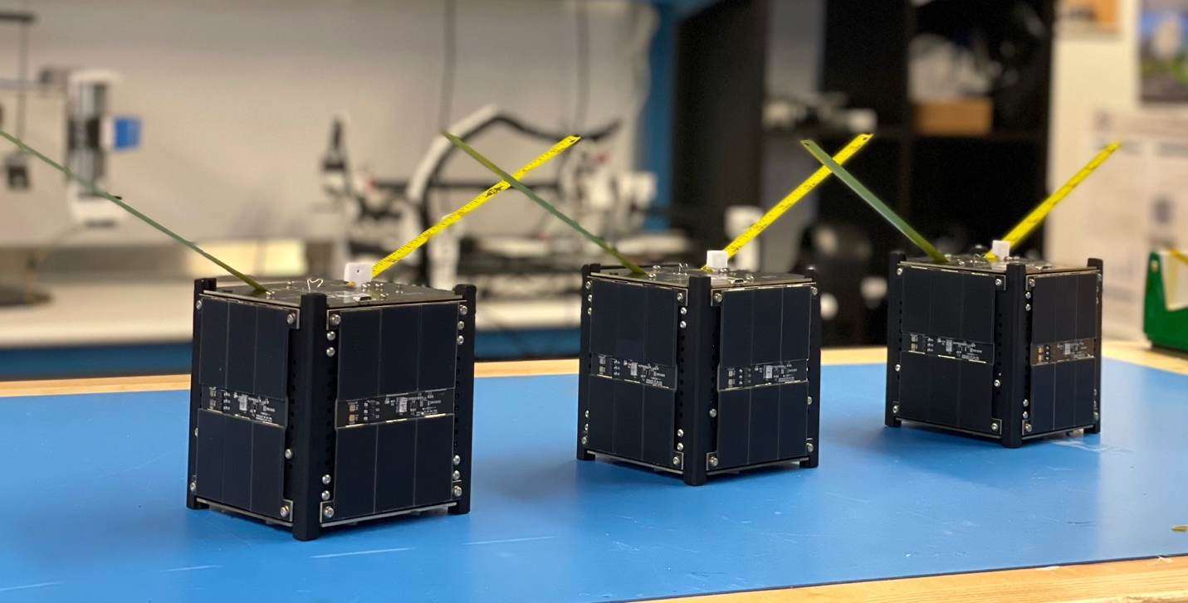

Produced: 7/23/2023

Table of Contents

Pre-Integration Assembly Procedures 1

Chapter 0: Parts & Tools – Pre-Integration Procedure 1

Chapter 1: EPS Board & Ballast – Pre-Integration Procedure 1

Chapter 2: Feet and RBF Switches and Battery Heater – Pre-Integration Procedure 1

Chapter 3: Solar – Pre-Integration Procedure 2

XY Faces 2

Z- Face 3

Chapter 4: Flight Controller – Pre-Integration Procedure 5

Chapter 5: Antennas – Pre-Integration Procedure 7

Chapter 6: Structure – Pre-Integration Procedure 10

Chapter 7: Testing – Pre-Integration Procedure 11

Solar Board Testing 11

Battery Board Testing 11

Flight Computer Testing 14

Flat Sat Testing 15

Pre-Integration Checklists 17

EPS – Pre-Integration Checklist 17

Ballast Battery Board – Pre-Integration Checklist 18

Solar – Pre-Integration Checklist 18

COMMS – Pre-Integration Checklist 18

Antenna Board – Pre-Integration Checklist 19

Structure – Pre-Integration Checklist 19

Integration Procedure 20

Chapter 8: Integration Procedure 20

Chapter 9: Final Tests – Integration Procedure 32

Final Check for Electronics 32

One Final Jig Test 34

Vibration Test 34

Long Range Communications Test 34

Thermal Vacuum Chamber Test 34

Integration Procedure Checklist 36

# Pre-Integration Assembly Procedures

Before completing the pre-integration procedures, please review the included parts list to ensure all the components on the list have been included in the kit prior to integration. An additional part list will be included below in Chapter 0 that will be required of the user to ensure they have all the necessary materials before proceeding. The Owner’s Manual should also be reviewed prior to continuing for awareness of nomenclature.

## Chapter 0: Parts & Tools – Pre-Integration Procedure

In addition to the included parts of the kit, the User will be required to obtain:

* 1 Micro SD Card
* 1 Micro Type B USB cable
* 1 Tape Measure
* 1 Jig

The Jig can be obtained from our documentation repository at [www.github.com/proveskit](http://www.github.com/proveskit).

The User will need the following tools prior to proceeding:

* Soldering Iron
* Lead Based Solder
* Reflow Oven
* Low Temperature Lead Based Solder Paste
* T6 Torx Head Screwdriver
* T8 Torx Head Screwdriver
* Philips Head Screwdriver
* Flush Cutters
* Sandpaper or Dremel
* M3 Hole punch
* Hammer
* Needle Nose Tweezers
* Loctite
* Space Rated Glue
* Multimeter
* Power Supply
* Proper Protective Equipment

## Chapter 1: EPS Board & Ballast – Pre-Integration Procedure

In this chapter, the user will learn the proper steps to assemble an Electrical Power System (EPS) board. The steps can be followed again to create an optional ballast to add weight to the satellite, or while not recommended, additional power to the satellite.

Before continuing, it is important to note that gloves should worn when soldering and it should be done in a well-ventilated area to avoid the harmful fumes.

* 1. Soldering the Relay
     1. Insert the relay from the top side as seen in Figure 1.1
     2. The Relay on the EPS board has through hole connections that will need to be soldered to on the bottom side as seen in Figure 1.2
     3. After Soldering, use the flush cutters to cut the leads from the relay and try to get relay solder joints as flush to the board as possible as seen in Figure 1.3
  2. Soldering the Battery Holders
     1. Insert the battery holders into the board as seen in Figure 1.4
     2. Solder the through hole battery terminals on the top side of the EPS as seen in Figure 1.5
  3. OPTIONAL: Ballast Board creation
     1. Follow all of the prior steps to create a secondary EPS
     2. If additional power is desired for the satellite, a wire can be soldered to the Pack+ Test point between both boards, and a wire can be soldered to the B- Test point between both boards.

If all steps were followed correctly, the EPS should appear as it does in Figure 1.6.

## Chapter 2: Feet and RBF Switches and Battery Heater – Pre-Integration Procedure

In this chapter the user will learn the steps to assemble a foot switch. A minimum of two will be needed for any space application, but four switches would be recommended to increase redundancy.

Before continuing, it is important to note that gloves should worn when soldering and it should be done in a well-ventilated area to avoid the harmful fumes.

1. Make 4-6 Jumped 2 Position Pico-Lock Cable Assemblies
   1. 300mm 5 position Pico-Lock cable assemblies have been included in the kit as well as 2 position connectors. The 100mm assemblies will be used for connecting the solar boards to the EPS, and the 300mm assemblies will be used to create all the needed 2 position Pico-Lock assemblies. The first step will require taking a cable out of the 300mm 5 position assembly. To start, take the needle nose tweezers and lift the locking mechanism as seen in Figure 2.1 and pull the cable from each connector housing.
   2. Take the freed cable and insert both ends into one 2 position connector housing as seen in Figure 2.2
   3. NOTE: The steps are similar for creating the non-jumped cables required for the burn wire and direct charging ports. The primary difference is that two cables will be required as well as 2 connector housings. The non-Jumped assemblies can be seen in Figure 2.3
2. Solder the Jumped Pico-Lock Assemblies to the switches
   1. Take jumped assembly and cut in half as seen in Figure 2.4
   2. Strip ends of assembly wires
   3. Slide heat shrink tubing down each wire
   4. Wrap wires around leads 1 and 3 respectively as seen in Figure 2.5
   5. Solder wires to switch leads
   6. Move heat shrink tubing up and use hot air to shrink tubing around switch leads
   7. Repeat these steps to create 2-4 foot switches and 1 RBF switch
3. Solder the Battery Heater Assembly
   1. Take jumped assembly and cut in half as seen in Figure 2.4
   2. Strip ends of assembly wires
   3. Slide heat shrink tubing down each wire
   4. Strip ends of battery heater leads
   5. Wrap wires around leads as seen in Figure 2.6
   6. Solder wires to heater leads
   7. Move heat shrink tubing up and use hot air to shrink tubing around heater leads
4. Create Foot Switch Assemblies
   1. Insert the M2x20 bolts into the holes of the non-embedded feet as seen in Figure 2.7
   2. With the bolt inserted, apply some Loctite to the bolt on the opposite end
   3. Holding the bolt in place with a Philips head screwdriver, insert the M2 lock nut into the opposite end of the foot and tighten the nut partially without allowing the bolt to go completely through the lock nut as seen in Figures 2.8 and 2.9
   4. Prepare a small amount of space rated glue
   5. Apply the glue to the inside of the foot on the areas shown in Figure 2.10
   6. Insert the switch into the foot as seen in Figure 2.11
   7. Repeat steps for all foot switches
   8. Insert all foot switch assemblies into the reflow oven and bake at 185C this will help cure the glue faster.
   9. Let rest for an additional hour
5. Create RBF Switch assembly
   1. Insert RBF switch into holder as seen in Figure 2.12
   2. Insert and fasten M2.5x8 or M2.5x10 bolts into the 3d printed side. The assembly can be seen in Figure 2.13

## Chapter 3: Solar – Pre-Integration Procedure

Before continuing, it is important to note that gloves should be worn prior to applying solder paste to avoid ingestion of a lead-based material.

### XY Faces

1. Hand solder pico-lock connector following silkscreen and pad outlines.
   1. Follow the silkscreen pattern on the board to place the components in the correct positions/orientations. For the pico-lock connectors line up the mounting pads when soldering connectors.

**WARNING:** Test all sensors for full functionality prior to solar cell installation (see Chapter 7 that identifies the proper test to complete for the solar boards). If sensors are faulty and need to be reflowed or removed with a heat gun, the cells will be damaged in the process.

1. Install the Solar Cells (KXOB101K08F-TR) using low temperature solder paste and a reflow oven.
   1. Apply Low Temperature Solder Paste to the pads on the Solar Board as seen in Figure 3.1

Figure 3.1 Before and After Solder Paste application

* 1. Check that the positive and negative terminals on the back side of the cells are matched with the plus and minus silk screened on the PCB (Note: you cannot tell the orientation of the cell from the top of the cell, so make sure it is placed properly)
  2. For cells that are immediately next to each other, scoot them together so that the gap between them is as small as possible. Otherwise, the fishing wire to stow the antenna may get caught in the cracks
  3. Reflow on low heat (the low temperature for the solder that you use is recommended) and do not touch until completely cool. Figure 3.2 illustrates a correctly populated board.

Figure 3.2 Properly Populated Solar Board

NOTE: Since the cells can't handle a lot of heat. We have done a reflow with low temp solder paste at 185C and would recommend this as well.

1. OPTIONAL: Remove 0 ohm resistor for motor driver as seen in Figure 3.3
   1. If the solar board has already been removed from the oven, the resistor can be removed by a fine tip soldering iron heating each pad simultaneously. If the board is still hot from the oven, tweezers can be used very swiftly to remove the resistor.

NOTE: This step is completely optional as the magnetorquers can be deactivated in software. Only one X Magnetorquer and one perpendicular Y Magnetorquer need to remain active in order to detumble the satellite effectively. The Z- Solar board should let the magnetorquer coil remain active, as this is the only coil on the Z faces.

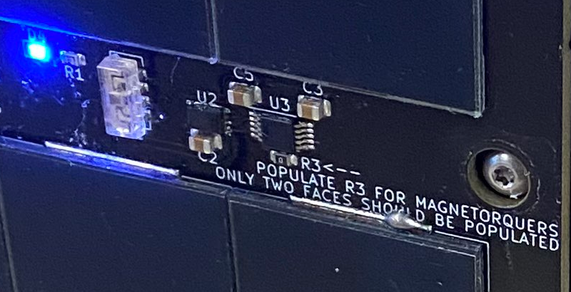

Figure 3.3: Motor Driver Circuitry

### Z- Face

In this section, the Z- Solar Boards will be completed.

**WARNING:** Test all sensors for full functionality prior to solar cell installation (see Chapter 7 that identifies the proper test to complete for the solar boards). If sensors are faulty and need to be reflowed or removed with a heat gun, the cells will be damaged in the process.

1. Install the Solar Cells (KXOB101K08F-TR) using low temperature solder paste and a reflow oven.
   1. Apply Low Temperature Solder Paste to the pads on the Solar Board as seen in Figure 3.4

Figure 3.4 Before and After Solder Paste application

* 1. Check that the positive and negative terminals on the back side of the cells are matched with the plus and minus silk screened on the PCB (Note: you cannot tell the orientation of the cell from the top of the cell, so make sure it is placed properly)
  2. For cells that are immediately next to each other, scoot them together so that the gap between them is as small as possible. Otherwise, the fishing wire to stow the antenna may get caught in the cracks
  3. Reflow on low heat (the low temperature for the solder that you use is recommended) and do not touch until completely cool. Figure 3.5 illustrates a correctly populated board.

Figure 3.5 Properly Populated Solar Board

NOTE: Since the cells can't handle a lot of heat. We have done a reflow with low temp solder paste at 185C and would recommend this as well.

1. Install the Two Position Screw Terminal on the bottom side of the board as seen in Figure 3.6

Figure 3.6 Properly Populated Screw Terminal

NOTE: Two different screw terminal footprints are available as options depending on preference

## Chapter 4: Flight Controller – Pre-Integration Procedure

1. Install NeoPixel and VL6180 LiDAR
   1. Apply Low-Temperature Solder Paste to both part pads as seen in figure 4.1

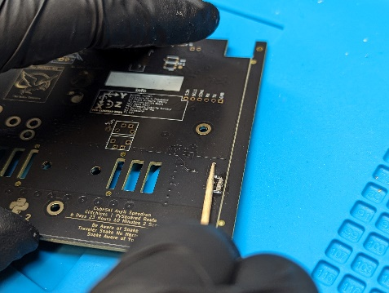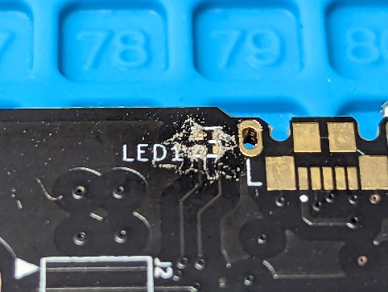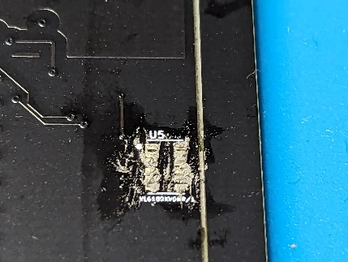

Figure 4.1: Application of Low Temp Solder Paste

* 1. Place components in proper orientation as seen in figures 4.2 and 4.3
  2. Place Standoffs in reflow oven (this is to avoid letting the board touch the oven tray)
  3. Place board on standoffs and set the oven to 185C or temperature slightly above solder paste’s recommended temperature.

NOTE: The NeoPixel does not need to be populated but can be utilized by the Flight Controller to show the status of the system.

1. Hand Solder the Micro USB port
   1. Pre-tin the pads of the Micro USB port as seen in Figure 4.4

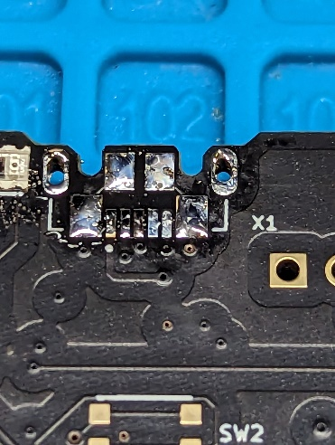

Figure 4.4: Pre-tinned pads

* 1. Insert USB onto Footprint and flip board over as seen in Figure 4.5

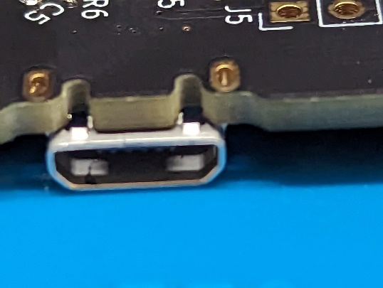

Figure 4.5: USB Orientation upside down

* 1. Solder through hole pins of USB to ensure structural stability of connector as seen in Figure 4.6

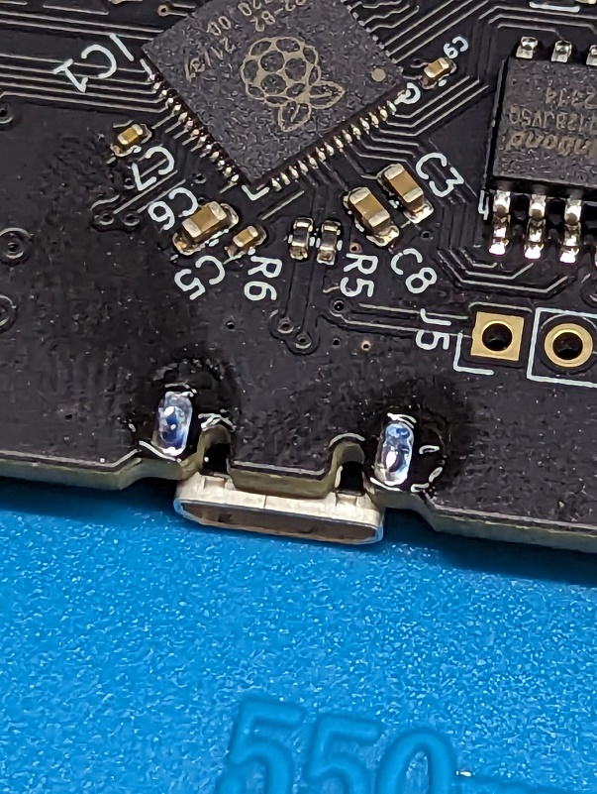

Figure 4.6: Soldered USB Structural Supports

* 1. Flip Board over, and apply hot air to the connector while holding the connector down with a pair of tweezers as seen in Figure 4.7

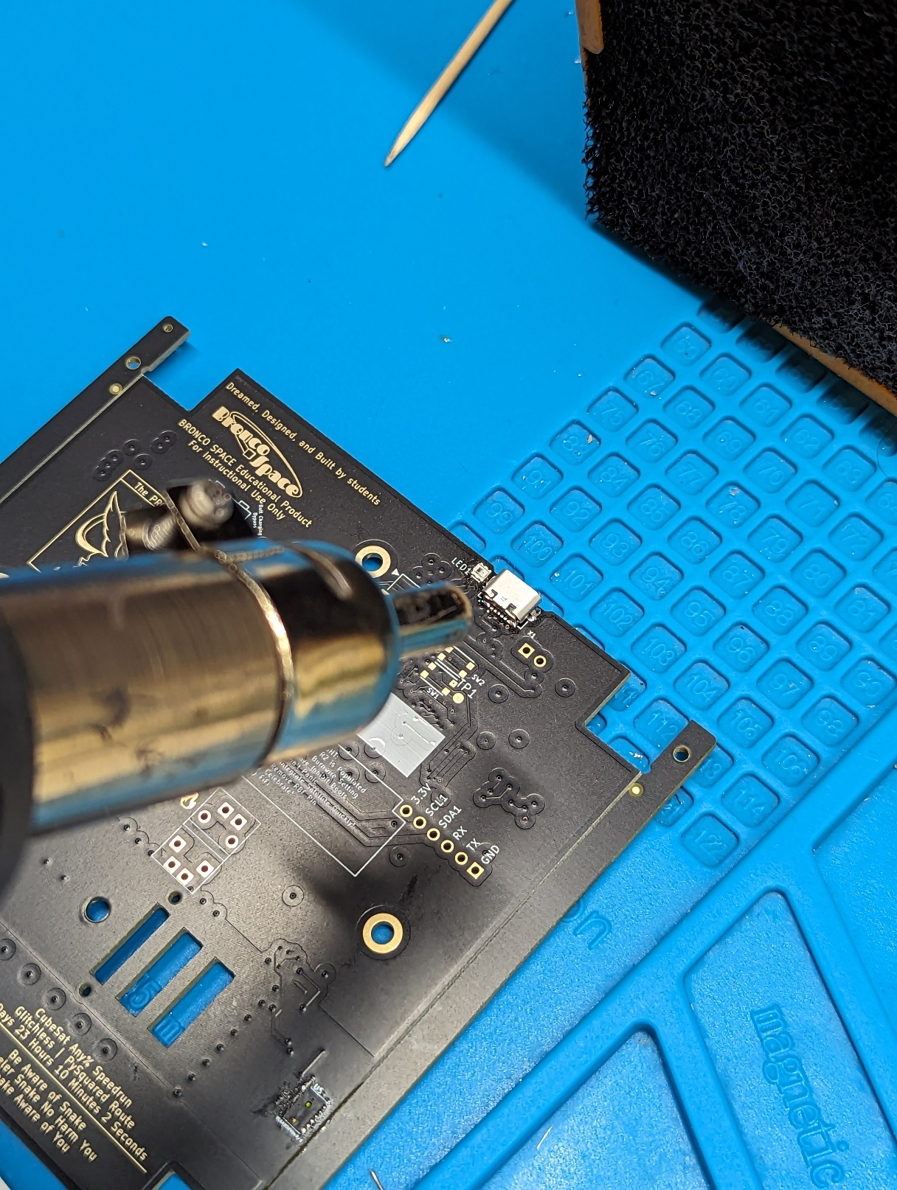

Figure 4.7: Applying Hot Air

* 1. After removing the heat, the connector should be adequately Soldered to the Board and should appear as in Figure 4.8

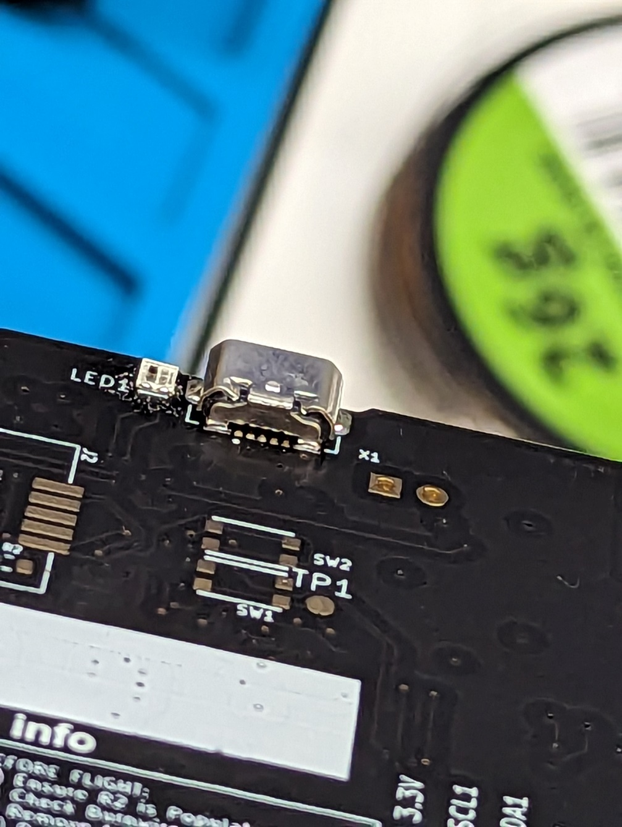

Figure 4.8: Final Appearance

1. Loading the Firmware onto the board
   1. After soldering the USB connector onto the board, the flight controller can be plugged into the computer, and power should enter the system by jumping the pins of J? as seen in Figure 4.9
   2. A Blue LED should then turn on as seen in Figure 4.10, and the file system RP1-RP2 should be detected as seen in Figure 4.11
   3. Drag and Drop a UF2 file into the file system. Several options for Firmware are available:

Firmware_WDT.UF2 is the firmware that activates the use of the Watchdog timer

Firmware_MRAM.UF2 is firmware that allows the use of MRAM memory on the flight controller, however this firmware is still undergoing testing and is considered experimental at the time of writing

Firmware.UF2 is the bare bones firmware that works as good as the rest, but doesn’t activate the Wathdog timer.

* 1. After dropping the firmware into the file system, a new file system should load with the name “Pysquared,” as seen in Figure 4.12
  2. Load Flight Software from the GitHub Repository onto the File system allowing all files to be replaced
  3. Open a new session on a terminal software (like Tabby Terminal) that can read the output from the flight controller. The output should look similar to that seen in Figure 4.13

NOTE: If the output is not like what is seen in Figure 4.13, try reloading the software by pressing ctrl+C and then ctrl+D

NOTE: The Firmware and Flight Software can be obtained on the GitHub: [www.github.com/proveskit](http://www.github.com/proveskit)

1. Hand Solder the Balun
   1. Follow the silkscreen pattern on the board to place the component in the correct position. The dot should be facing outwards from the PCB and towards the USB port side of the board as seen in Figure 4.14
   2. Solder the Balun to the board. Using Tweezers can help hold the balun down while applying heat
2. Install the Hope RF Radio module
   1. If you are using the Enhanced Power Module (fits the longer of the two usable footprints on the PCB), use Kapton tape to cover the smaller set of pads that would sit under the Radio Module (see Figure 4.15 for which pads). If using any other module, then apply Kapton tape to the giant rectangular pad next to the pad set in Figure 4.15.

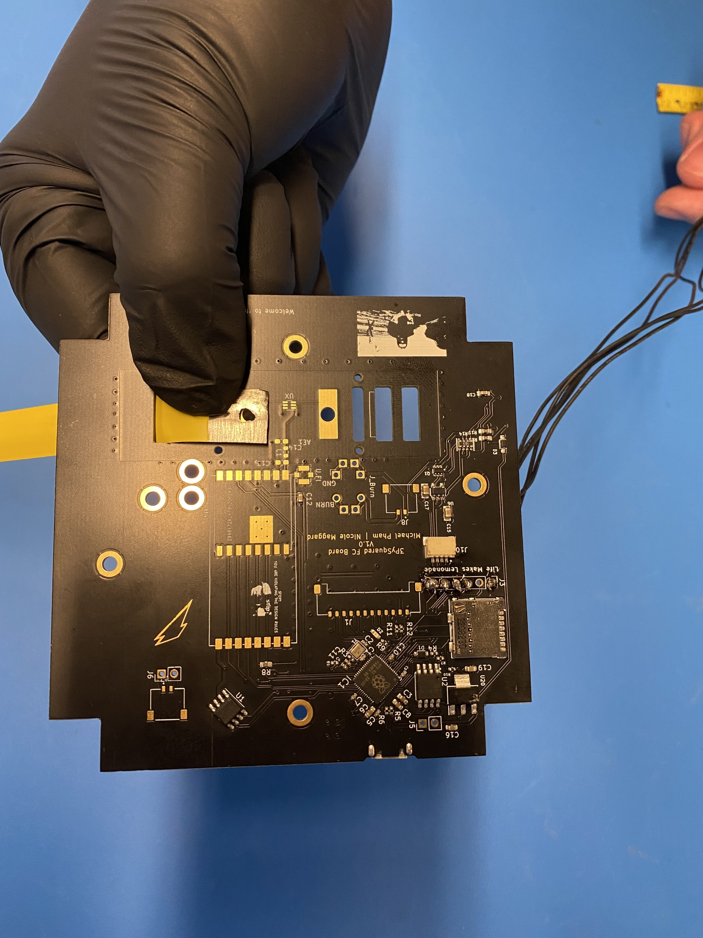

Figure 4.15: Radio Pads

RECOMMENDED: For builds intended for flight, to increase efficiency, it is recommended to remove the 3.3-volt regulator from the module (only on the enhanced power modules)

* 1. Hand solder radio into place and should appear like either Figure 4.16 or 4.17
  2. If using the smaller radio module, then a Jumper wire should be soldered to the pads as seen in Figure 4.18

**WARNING:** If using the smaller radio module, it is imperative that the user does NOT plug in the 12 position Molex Picolock connector UNTIL following the next step in which the cable assembly will be modified. If the user fails to follow the next step, the 5V power from the battery board will short with the 3.3V power.

* 1. If using the smaller radio module, the following cable seen in Figure 4.19 should be removed from the cable assembly and that side SPECIFICALLY should be inserted into the flight controller as seen in Figure 4.20

1. Solder two position Pico-Lock headers
   1. Follow the silkscreen pattern on the board to place the two headers in the correct positions/orientations and solder them into place. The connectors should appear as they do in Figure 4.21
2. Solder the Burn Wire to the Flight Controller Board
   1. Insert some Nichrome wire into the hole seen in Figure 4.22
   2. Bend the wire on the opposite side of the board and insert into adjacent hole and pull tight as seen in Figure 4.23
   3. Create a large loop on the top side of the board and insert the wire back into the board as seen in Figure 4.24
   4. Bend the wire into the adjacent hole and pull tight as seen in Figure 4.25
   5. Solder the Wire at all Pads on the top and bottom of the board. Also snip ends of wires so that it appears like Figure 4.26
   6. Press down on center of wire loop on the top side of the board as seen in Figure 4.27

## Chapter 5: Antennas – Pre-Integration Procedure

1. Cutting and Drilling the Antenna
   1. Using a Milwaukee 6ft keychain measuring tape. Completely pull out the tape measure from the keychain.
   2. Cut the measuring tape into 180mm lengths using a pair of scissors. These will need to be shortened down to a size correlated to the radio frequency. For example: the antenna lengths need to be 165mm to broadcast in the 437.4MHz range. Only 2 lengths are necessary for the satellite, however it’s best to use all of it in case there is a mistake. If you are interested in broadcasting in other frequencies use a dipole antenna calculator to find out the proper element length for your desired frequency.

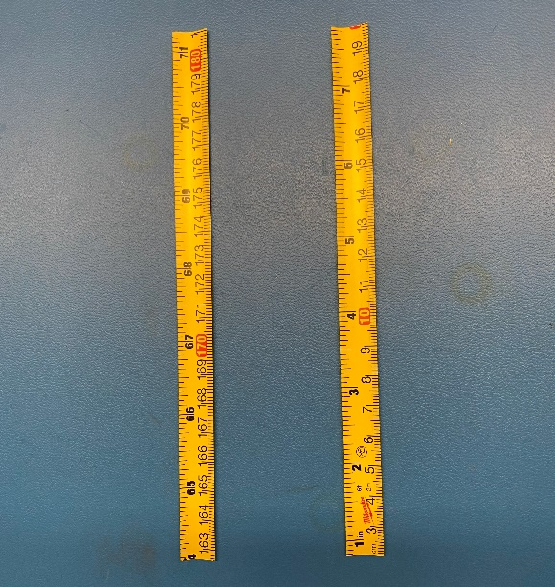

Figure 5.1: Lengths of measuring tape cut for use as antenna.

NOTE: After attaching the antenna you may need to shorten the antenna, but this can be done later.

* 1. Using a Dremel or sandpaper, sand off roughly ½-inch of the paint off the end of the measuring tape. Sandpaper may also work, but it will probably take much longer to do. Do the same to the opposite side of the measuring tape.

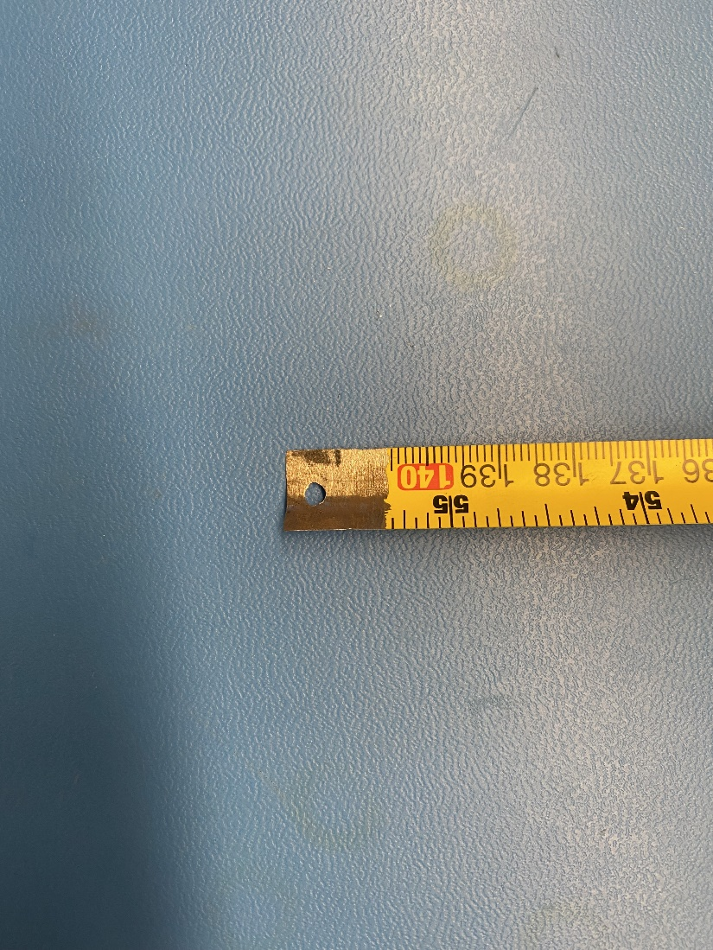

Figure 5.2: Antenna length with sanded end and mount hole after drilling.

* 1. After sanding off the paint so the aluminum is bare, using a M3 sized drill bit. Drill a hole through the exposed aluminum roughly 1-3mm away from the end of the length of measuring tape. We advise doing this nearest to edge as possible without causing it to split/tear.

**WARNING:** The hole may tear because of the drill bit gripping onto it, if this does happen you will need to start over with a new length of measuring tape or try utilizing a hole punch.

* 1. To drill the hole in the tape we typically use a drill press, however a hole punch with the proper diameter or a handheld drill should work, although it may be more difficult to do so.
  2. Now, using either a Dremel or sandpaper, sand off the paint on the opposite side of the hole that you just drilled. After having done these steps with at least 2 lengths it is now time to solder them to the top cap of the satellite.

1. Soldering Antenna to Board
   * 1. First feed the drilled side of the measuring tape through the outermost rectangular hole of the Top Cap. Make sure to feed it through the outward-facing side of the Top Cap so when the Top Cap is flipped over, the drilled hole of the antenna lines up with the open hole on the inward-facing side of the Top Cap. This step is shown more clearly in Fig5.3.

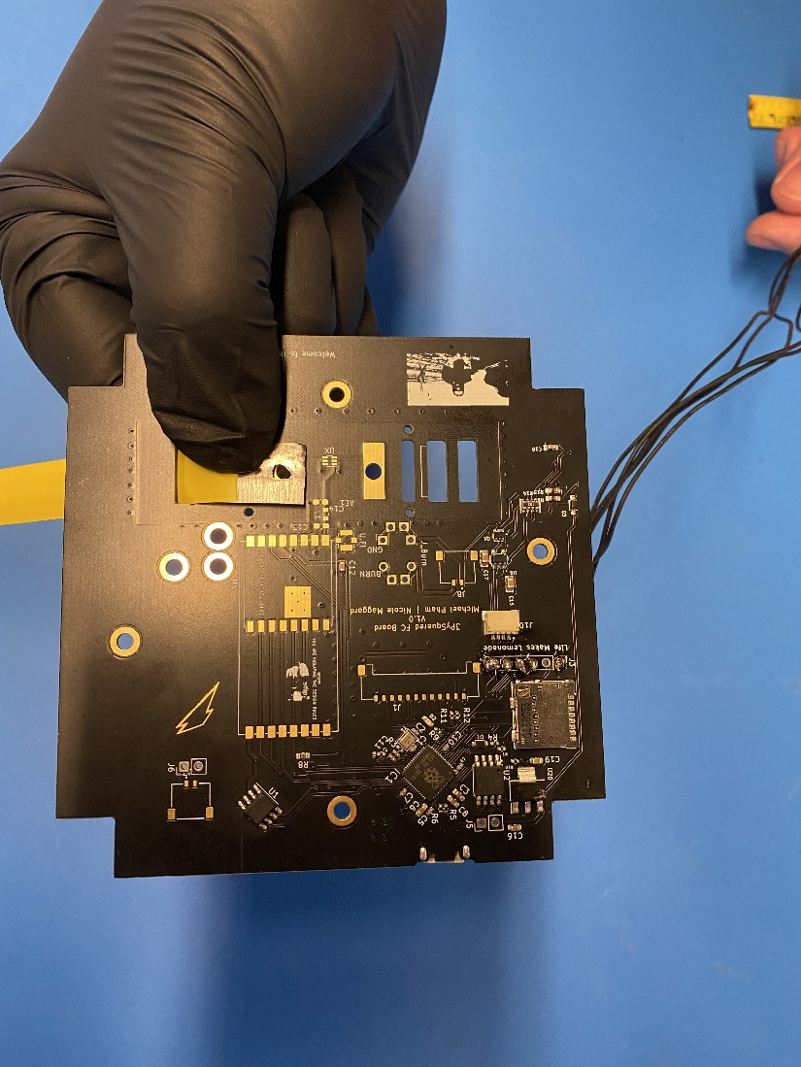

Figure 5.3 Initial insert of antenna in Top Cap before soldering.

* + 1. Now, you must hold the antenna in place to solder it to the board. We again suggest either having someone hold it in place, so it rests flush again the Top Cap or using a c-clamp to hold it as you are soldering.
    2. After doing this repeat step 6 with the other length of measuring tape for the 2nd antenna of the satellite.
    3. OPTIONAL: Secure the two antennas to the top-cap by feeding a white 2.5mm nylon screw through the outward facing side of the top-cap and secure it with a matching white 2.5mm nylon nut.

## Chapter 6: Structure – Pre-Integration Procedure

1. Cataloging parts:
   1. The Structure
      1. Measure the dimensions of each half of the anodized Main “U” structure and label them. We advise doing this by using calipers to measure the width of each of the two sheet metal halves.
      2. Figure 6.1 shows an example measurement of the width using calipers as well as other dimensions of the structure, the additional measurements however will not be necessary as a part of integration they are just useful verify your satellite will fit inside a launch vehicle pod after integration is complete and to ensure no damage during shipping has occurred.

**WARNING:** Make sure not to bend the U-shape inwards when measuring as this will ruin the measurement. Take the measurement as close to the “closed” side of the U as possible. Below is an example table.

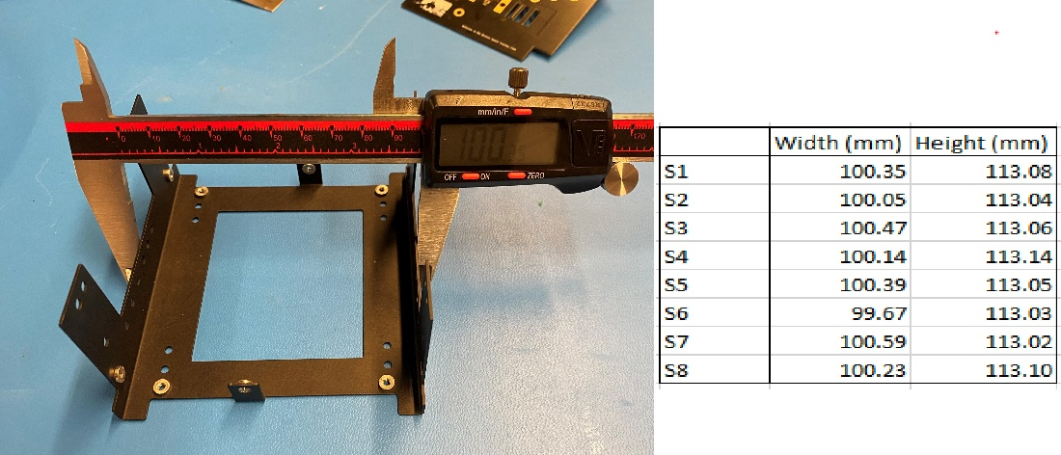

Figure 6.1 Example measurements of Main “U” structure.

NOTE: The steps below are for if you are planning on flying your satellite and have more than two Main “U” structure halves. If you only have two halves you can move onto part 2 of the pre-integration procedure.

* + 1. Record and identify which structures are optimal for flight. The structures should come in at about 99.77mm nominally but they will vary depending on the bends and the anodizing.
  1. Checking out the PEM-Nuts
     1. The structure and brackets all contain PEM-Nuts, the diagram on Figure 6.2 identifies all the locations for the PEM-Nuts.
     2. If a PEM-Nut has come off, an M2.5 Lock Nut can be used instead, or the PEM-Nut can be pressed back into place using an arbor press
  2. Obtaining the Jig
     1. Access the GitHub Documentation repository where an stl file can be obtained and printed for the jig.

NOTE: The Jig will become very important for ensuring the satellite is squared up enough to fit inside a launch pod.

## Chapter 7: Testing – Pre-Integration Procedure

### Solar Board Testing

To test the solar panels on the satellite we will simply require a voltmeter to measure the voltage across all the cells. There are two bare metal pads on each board that houses the six solar cells. One of these pads is labelled VSOLAR while the other is labelled GND. The steps to test the cells is as follows:

1. Bring the Solar board into direct sunlight (NOTE: if direct sunlight is unavailable, a bright light from a car’s high beams may suffice for testing, but may return a lower-than-normal voltage reading and may leave the test results inconclusive)
2. Without placing a shadow on any of the cells, place the positive probe of the voltmeter on the VSOLAR pad, and the negative probe on the GND pad
3. Ensure the voltage being read is above 10V. If the reading is 10V or above, then the test is complete, and the cells on the solar board are functioning properly. If the reading is significantly less than 10V, then continue to the following steps for troubleshooting:
4. Ensure cells are unobscured from sunlight
5. Ensure proper contact of probes to bare test pads
6. Testing the voltage across individual cells may become necessary:
7. Identify the pads above and below each cell
8. Place each probe on each pad
9. If voltage reads close to 0 in direct sunlight then the probe may not be in contact of the pad or the cell is broken and the board must be replaced. (NOTE: replacing the cell may be possible, but is not advised as re-exposing the other cells to the reflow oven temperatures may cause unintended damage)
10. Repeat steps 1 through 3 for each solar board

### Battery Board Testing

Information about healthy batteries:

3-3.2V=Danger Zone

3.2-3.4V=Low

3.4-3.7V=Normal

3.7-4V=High

4-4.2V=Danger Zone

The cells may end up in the danger zone for one of two reasons:

* Undervoltage
* Overvoltage

Undervoltage is a concern for the health of the battery, but not a safety concern.

Overvoltage is a concern for the health of the battery and the safety of the people around the battery. Allowing the battery to overcharge can cause the battery to explode.

CAUTION: Before proceeding with this test, ensure the batteries you utilize in this test all have a voltage of 3.4V and above, and are balanced (i.e. each cell is within +- 0.05V from each other).

The main thing to verify in testing the battery board is that the battery protection network is operating as expected and that the voltage regulation is also functioning properly. To test the Battery board, follow these steps:

1. Insert Batteries into the battery holders on the bottom side of the board, starting on the right side and inserting each one towards the left. Make sure to follow the posted polarity on the board. Failure to insert batteries in the correct polarity may pose safety concerns and cause severe problems for the board.
2. To check that the batteries are now connected to the board, start by flipping the board over and observing the various test points on the board.
3. Use a voltmeter to test the pack voltage. Place the positive probe into the PACK+ test point on the board and place the negative probe into the B- test point. This voltage should be greater than 6V.
4. If the pack voltage is above 6V then the batteries are properly connected to the board and you may proceed to the next test of the board. If the pack voltage is below 6V then please follow these steps for troubleshooting:
5. If the voltage is below 6V and not at 0V then your cells may be in an undervoltage state and may require a recharge before continuing
6. If the voltage is at 0V, then one or more cells may be disconnected from the board. In this case, ensure the batteries are inserted with the correct polarity, and that the solder joints for the battery packs looking like they are making a strong connection
7. Test the voltages across each cell and ensure that these are not 0V. If any cell is sitting at 0V, then this battery should be replaced. If the cells do not sit at 0V, then the battery board may need to be replaced, as an issue may exist with the traces on the Printed Circuit Board.
8. To check that the battery protection is functioning properly, we will now test the pack voltage against ground:
9. Place the positive probe into the PACK+ test point on the board and place the negative probe into the GND test point. This voltage should be the same as the pack voltage.
10. If the voltage read is the same as the pack voltage, then the battery protection is functioning properly. If the voltage is not the same as the pack voltage, then the battery protection may be triggering either the over charge or over discharge protections and the following steps should be followed to troubleshoot:
11. To test these conditions, the user will have to be very careful with probing the MOSFETs in the area titled “Battery protection” on the top side of the board. To test the protections, the negative probe will be placed on PACK- test point. The following image shows which pin to touch the positive probe to, to identify an over charge state:

The following image shows which pin to touch the positive probe to, to identify an over discharge state:

If there is voltage read at either of these pins, then the corresponding protection has been triggered and the batteries should be removed for 10 minutes. Once 10 minutes has passed, replace the batteries and restart the test.

1. If no protection is triggered, then the battery protection IC may be faulty and the board needs to be replaced.
2. If a protection is continuously triggered and there are no “accidental” short circuits, then the board is faulty and needs to be replaced.
3. Jump J18 on the top side of the board with a jumper to bypass the feet switches and RBF switch to supply power to the board’s circuitry
4. To test that the voltage regulation is functioning properly, we will now be testing the 3.3V on the board:
5. Place the positive probe into the 3.3V test point on the board and place the negative probe into the GND test point.
6. If this voltage does not read 3.3V, then these steps should be followed to troubleshoot:
7. Ensure that battery protection has not triggered (step 3)
8. Probe the VBUS test point against ground to ensure that the pack voltage is passing through to the system
9. If 3.3V is still not generated, then the regulator may be faulty and the board needs to be replaced.
10. This step is optional, but tests the functionality of the Feet switches and the RBF switch:
11. Remove the J18 jumper and plug in all of the feet switches into the top 4 two position Molex Pico-Lock connector housing
12. The RBF will also connect into its two position Molex Pico-Lock connector housing.
13. Leaving all of the switches undepressed, probe all of the test points against GND. All of these should read their respective values.
14. Depress the RBF switch and probe again, all of the test points should read 0V when compared to GND.
15. Release the RBF switch and depress three of the feet switches and observe the same test point voltages. A second person may required to help with this step.
16. If it seems the switches are not functioning properly then they should be replaced.
17. Remove the J18 Jumper (or the switches if step 6 was done), and remove the batteries starting on the left and moving to the right.

### 

### Flight Computer Testing

The main goal of testing the Flight Computer, is ensuring that the board receives power and that the board is loaded with the correct firmware. The following steps should be followed to test the Flight Computer:

1. Jump J? on the top side of the Flight Computer to allow the board to be supplied power from the USB
2. Plug in the Micro USB end into the Flight Computer board and plug the USB-A end into a computer
3. Ensure the LED on the bottom side of the board is illuminated. If it is not, then the board is not powered, and the following should be checked:
4. Check that J? is being jumped
5. Check the solder joints on the USB connector and reflow the solder joints if necessary
6. If the board is powered, the Computer should also identify a new disk drive called PYSQUARED. If the computer does not recognize the device, or shows up with a different drive name, then the following steps should be followed:
7. If the drive shows up as RP1-RP2, then the firmware needs to be reflashed and this can be done by simply dropping the firmware.uf2 file for the device into the folder. If the device shows up as RP1-RP2 again, then the device is broken and the board needs to be replaced.
8. If the device is not detected on the computer, then it may become necessary to reflow the solder joints of Micro USB connector on the board.
9. If the device is detected, but not recognized, then try reinstalling the device driver using the device manager on the computer. If this does not resolve the issue, then the board needs to be replaced.
10. If the device is detected and recognized as a “USB-DRIVE” then the microcontroller is broken and the board should be replaced.
11. Open a terminal on the computer at the COM port of the Flight Computer (This can be found using the device manager).
12. In case software is running on the board please press Ctrl + C to interrupt the code and press enter to enter the REPL.
13. Once in the REPL, type “import board” and press enter
14. Now type “dir(board)” and this will bring up all of the pin and bus definitions in the firmware
15. If you got all of the definitions, then the Flight Computer board is operating normally. If there are errors or nothing appears in result of the commands, please follow these steps to troubleshoot:
16. Ensure the correct COMS port is selected
17. Ensure any code is interrupted, and that the REPL has been entered
18. Ensure there are no typos in the commands
19. Disconnect the Micro USB end from the Flight Computer, and disconnect the Jumper at J?

### Flat Sat Testing

The main Objective of this test is to connect all the electronics outside of the structure, to ensure that everything is operating normally before integration. This will test the ability to power all the components and get a read from all sensors. The steps in this test assume that the previous tests have been completed and were successful. This test also assumes that the antennas have been soldered to the Flight Computer, so if neither of these steps have been completed, please go back and complete these steps before moving forward:

1. Insert all the batteries into the battery board starting on the right and moving to the left.
2. Jump J18 on the battery board so we do not need to insert all the switches. The switches however could be inserted instead if these are desired to be included in the test (don’t jump J18 in this case).
3. Probe the 3.3V test point and confirm that the board is regulating the 3.3V bus
4. Plug the 12 position Molex Pico-Lock into the board and plug the other end into the Flight Computer Board. At this point, the Blue LED on the bottom of the Flight Computer should have illuminated.
5. Plug in all the 5 position Molex Pico-Lock connectors into the battery board. Then plug the other ends into the solar boards. The bottom connector must connect to Face4, and the other faces can go into the other connectors in any fashion. The LEDs on the solar faces may illuminate, but this is not completely expected until software is running. Don’t panic if the LEDs illuminate, as the driver used on the battery board may have been actuated by software on the Flight Computer.
6. Connect the Flight computer to a desktop using a Micro USB cable. The filesystem should appear once again.
7. Load the “FlatSatTest.py” file into the directory “PYSQUARED”
8. Open a terminal for the COM port connected to the satellite
9. Type the following command: “import flatsattest”
10. The following set of results should appear:
11. If the results do not appear successful for every component, follow these steps for troubleshooting:
12. The LED Driver may not be operating correctly, which may cause issues with being able to view sensor data from the solar boards as the sensors may not receive power. If the test did not return a success for initializing the LED Driver, then follow these steps:
13. Load the “I2Ctest.py” file into the “PYSQUARED” Directory
14. Type the following into the terminal “import i2ctest”
15. If the readout does not return an I2C address at 0x56 then the LED Driver is not working, and the battery board should be replaced
16. The I2C Multiplexer may not be operating correctly, which may cause issues with being able to view sensor data from the solar boards as the individual bus is not being selected properly. If the test did not return a success for initializing the I2C multiplexer, then follow these steps:
17. Load the “I2Ctest.py” file into the “PYSQUARED” Directory
18. Type the following into the terminal “import i2ctest”
19. If the readout does not return an I2C address at 0x72 then the I2C multiplexer is not working, and the battery board should be replaced
20. The solar board sensors may not be operating correctly, which can be an issue with either the solder joints on the sensors or an I2C fault. If the test did not return a success for initializing the temperature sensor, light sensor, or motor driver then follow these steps:
21. Load the “Solartest.py” file into the “PYSQUARED” Directory
22. Type the following into the terminal “import solartest”
23. If the readout does not return an I2C address at 0x26 then the Temperature sensor is not working. If the readout does not return an I2C address at 0x78 then the Light sensor is not working. If the readout does not return an I2C address at 0x20 then the motor driver is not working. In the case of the bottom face, if the readout does not return an I2C address at 0x35 then the ADC is not working for the Thermocouple.
24. If any of the sensors are not working, then check the solder joints on those sensors and reflow the sensors if necessary.
25. If resoldering the sensor does not resolve the issue, then it may become necessary to replace the solar board.
26. The power monitors may not be operating correctly, which may cause issues with being able to view data revolving the power usage and power input. If the test did not return a success for initializing input and/or output power monitors, then follow these steps:
27. Load the “I2Ctest.py” file into the “PYSQUARED” Directory
28. Type the following into the terminal “import i2ctest”
29. If the readout does not return an I2C address at 0x40 and/or at 0x4F then the one or more of the Power Monitors is not working and the battery board should be replaced

# Pre-Integration Checklists

## EPS – Pre-Integration Checklist

|  |  |  |  |
| --- | --- | --- | --- |
|  | Task | Notes | Initials |
|  | Batteries at an acceptable charge |  |  |
|  | Batteries epoxied into place |  |  |
|  | Battery holders securely attached |  |  |
|  | Thermocouple attached |  |  |
|  | Heating pad attached |  |  |
|  |  |  |  |
|  |  |  |  |
|  |  |  |  |

## Ballast Battery Board – Pre-Integration Checklist

|  |  |  |  |
| --- | --- | --- | --- |
|  | Task | Notes | Initials |
|  | Feet switches are soldered on |  |  |
|  |  |  |  |
|  |  |  |  |
|  |  |  |  |
|  |  |  |  |
|  |  |  |  |
|  |  |  |  |
|  |  |  |  |

## Solar – Pre-Integration Checklist

|  |  |  |  |
| --- | --- | --- | --- |
|  | Task | Notes | Initials |
|  | Test all sensors function |  |  |
|  | Test solar voltage is nominal | About 10 Volts in Sunlight |  |
|  | Epoxy pico-lock edges on top of solder mounting pads | Do not epoxy the data pads at the back. Do not get epoxy in the pico-lock |  |
|  |  |  |  |
|  |  |  |  |
|  |  |  |  |
|  |  |  |  |
|  |  |  |  |

## COMMS – Pre-Integration Checklist

|  |  |  |  |
| --- | --- | --- | --- |
|  | Task | Notes | Initials |
|  | Tape measure cut to correct size | Length: 180cm  Width: ?? |  |
|  | Holes drilled at both ends of the tape measure | Make sure one end has the edge of the hole cut for screwing down |  |
|  | End of tape measure sanded down |  |  |
|  | Tape measure screwed in and soldered |  |  |
|  | Balun soldered onto antenna board |  |  |
|  | SMA soldered onto antenna board |  |  |
|  | Nichrome wire soldered into burn wire | ** DO NOT TOUCH NICHROME WITH BARE HANDS** |  |
|  |  |  |  |

## Antenna Board – Pre-Integration Checklist

|  |  |  |  |
| --- | --- | --- | --- |
|  | Task | Notes | Initials |
|  | Antenna soldered to antenna board |  |  |
|  | Antenna length is at least 165mm | If at 165mm already, do not shorten them furter |  |
|  | Nylon screws and nuts secured to antenna |  |  |
|  |  |  |  |
|  |  |  |  |
|  |  |  |  |

## Structure – Pre-Integration Checklist

|  |  |  |  |
| --- | --- | --- | --- |
|  | Task | Notes | Initials |
|  | Inspect U’s and Feet for Scratches |  |  |
|  | Each Main “U” is labeled with its outer dimensions |  |  |
|  | The feet switches are glued into the appropriate feet |  |  |
|  | Check for missing PEM nuts |  |  |
|  | Battery boards are centered with respective brackets |  |  |
|  | All tools and hardware are ready for integration | The torque hexdriver, regular hexdriver, Loctite, fasteners are ready and nearby |  |
|  |  |  |  |
|  |  |  |  |

# Integration Procedure

## Chapter 8: Integration Procedure

1. **Building the Cube** 
   1. Initial structure assembly
      1. For this part of the integration, you will need two Main “U” halves, four small L-shaped brackets and stainless steel 5mm long M2.5 Button Head fasteners.

NOTE: It is extremely important that the button head fasteners are used in this step and NOT the pan head fasteners for the L Brackets as this will allow the Solar Boards to fit on top of the fasteners.

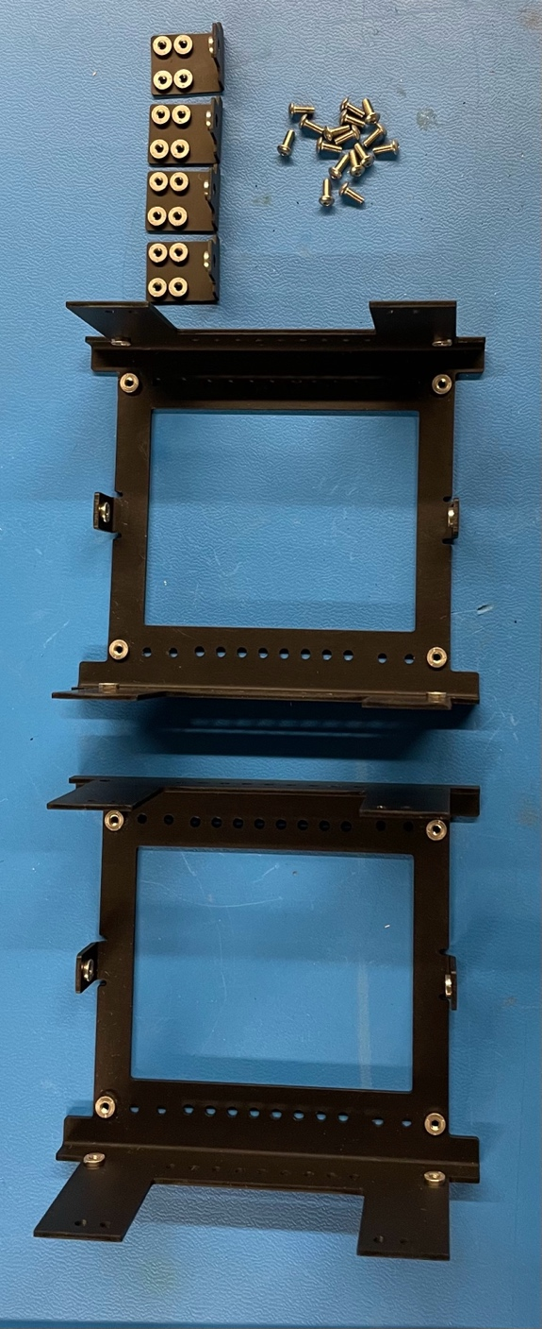

Fig 8.1: Main structure components

* + 1. Loosely attach the two halves together using the four L-brackets and 5mm fasteners as shown in figure 8.1 below. Insert fasteners into all the open slots where L brackets are located. Ensure note to over-tighten as we will “square up” the structure later using a jig.

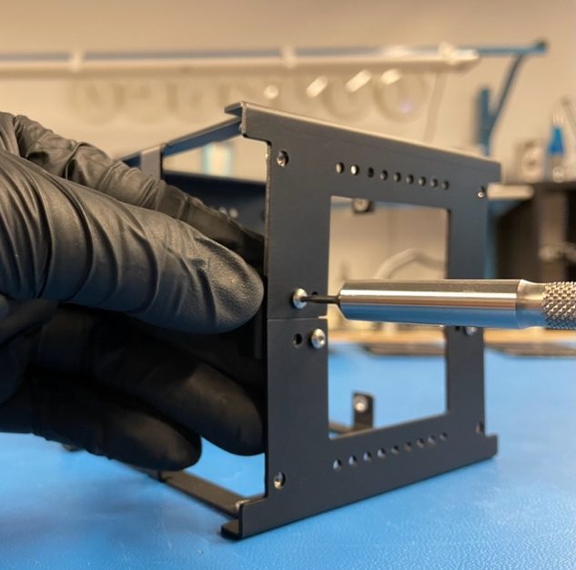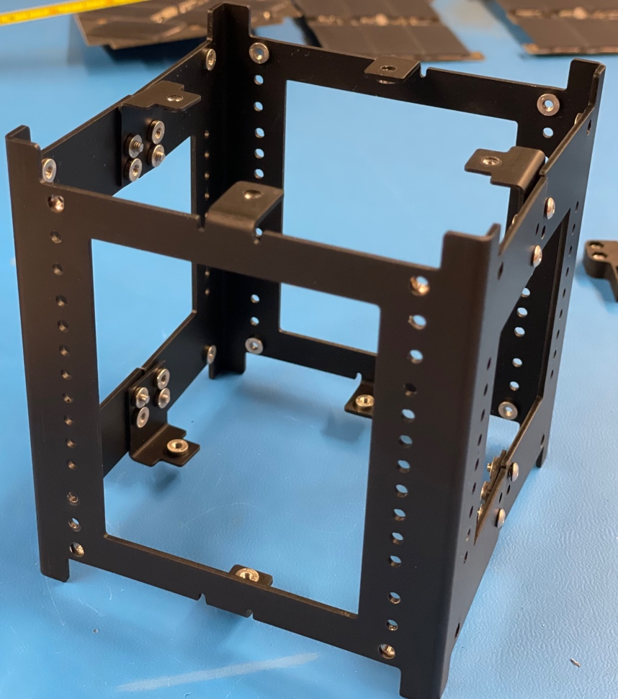

Figure 8.1: Example of how to attach the L brackets to initial structure assembly.

**WARNING:** Make sure to ALWAYS screw in the fasteners horizontally (along the worktable) when dealing with pre-installed pem-nuts as you will run the risk of popping one of them out of the L brackets. See figure 8.2 for the resulting error.

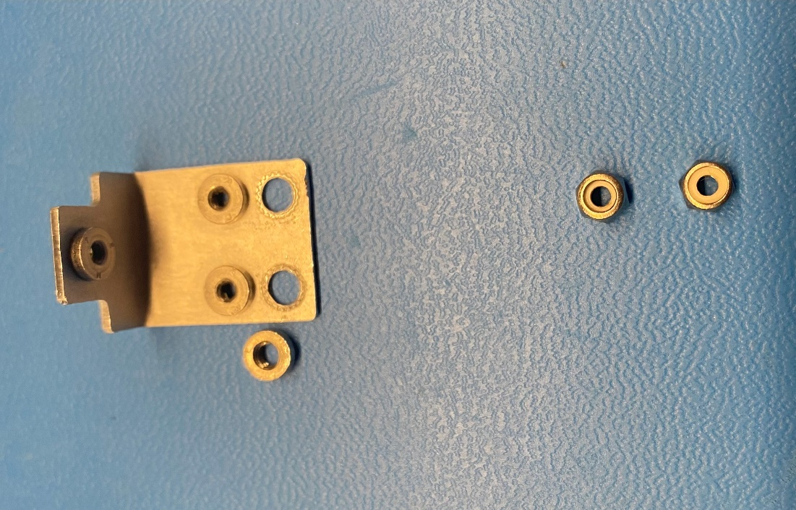

Figure 8.2: Left side shows small L-bracket with missing pem-nuts. On the right is two nylon locknuts that can be used instead if a pem-nut is lost, and the user is unable to press the pem nuts back in

* + 1. If you do happen to pop out one of the pem-nuts you will need to secure the fasteners with locknuts, but you should be extra careful not to tighten them too much as they are more difficult to take out when you square up the satellite.

1. **Card Brackets & Battery Board**

**WARNING:** Make sure to ALWAYS utilize a work table that is non-conducting when assembling electronics, specifically when batteries are involved.

* 1. Initial bracket mounting.
     1. Secure 2 battery board card brackets onto the board using M2.5x5mm Pan Head bolts as shown in Figure 8.3 below. Note that the angled tabs on the bracket attach to the board and the square tabs will attach to the structure. If preparing a satellite for space or testing, then the bolts should be dipped in Loctite prior to installation of the bracket to the board.

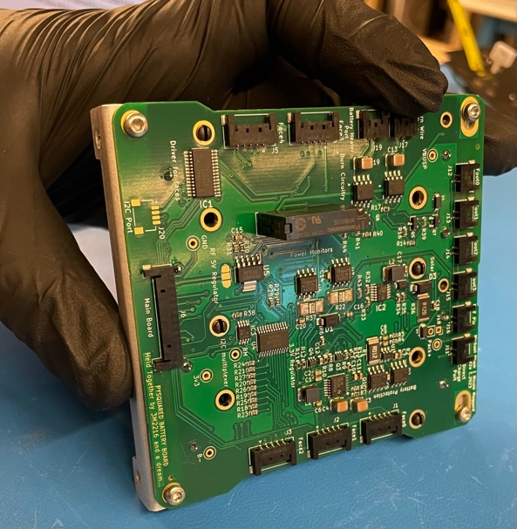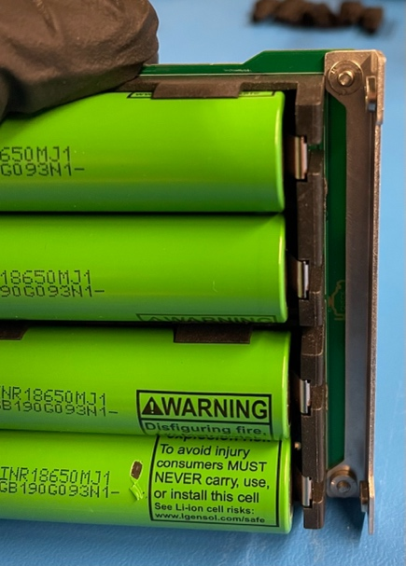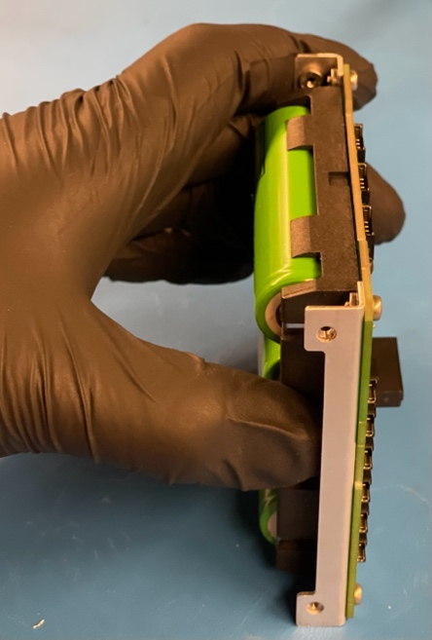

Figure 8.3: Initial Card Bracket Mount to Battery Board

* + 1. There are two separate approaches to this next step:
       1. angle the board diagonally with attached brackets and insert into the internal volume of the main structure. Use the board mounting holes on the main structure to secure the battery board using M2.5x5mm pan head bolts. There are several mounting hole options through the vertical length of the structure although the two holes extend further to the bottom on each corner of the structure should be reserved for mounting the feet. This can be seen in Figure 8.4 below along with the suggested positioning of the battery board.

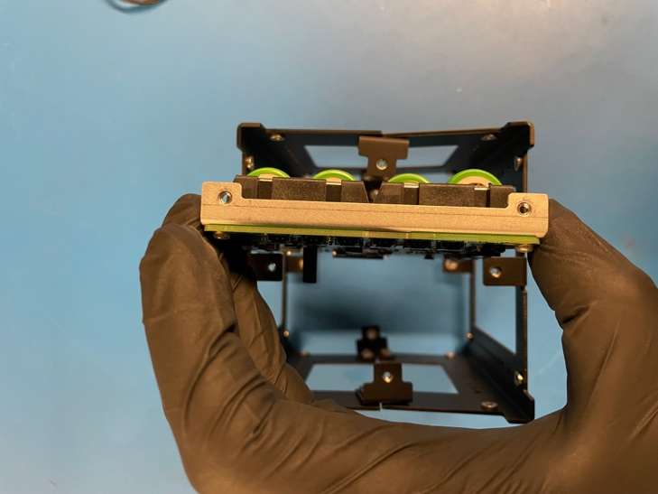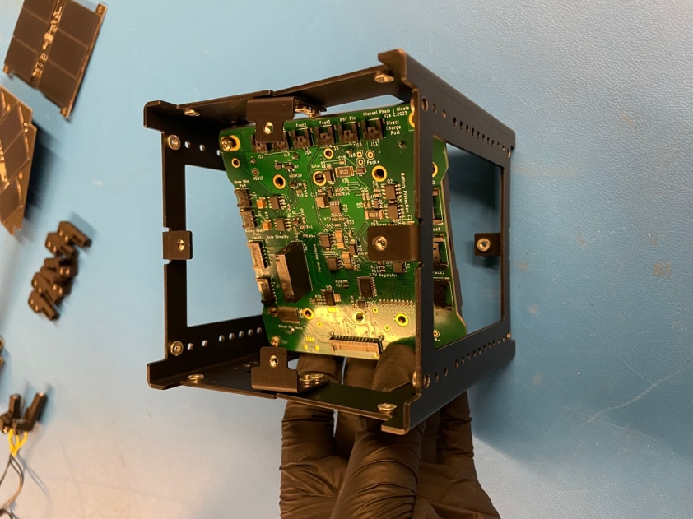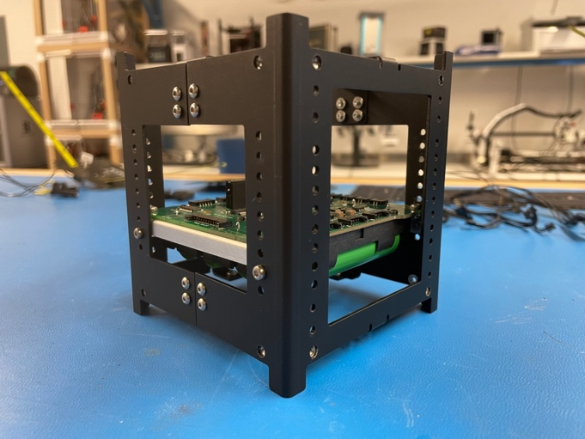

Figure 8.4: Approach 1 of Installing Battery Board Inside Structure

* + - 1. The second approach to inserting the battery board would be taking the Structure Halves apart and inserting the board along with any additional boards (battery board(s), development boards, payloads, etc.) into one of the Half U’s. Once the board is inserted, the holes on the bracket is aligned with the structure and fastened with the M2.5x5 Pan Head fasteners. The other Half U can be brought back in and installed like in the Building the Cube step, and the remaining bracket holes can be mounted to the structure. Figure 8.5 shows this process.

Figure 8.5: Approach 2 of Installing Battery Board Inside Structure

* 1. Applying Thermocouple
     1. Apply space rated glue to the Thermocouple and place on the side of one of the two middle batteries.
     2. Run Thermocouple cable along the side of battery, applying Kapton tape in the process. An example can be seen in Figure 8.6

Figure 8.6: Applied Thermocouple

* 1. Applying Thermal Blanket.
     1. For this part you will need a thermal blanket, Kapton tape, double-sided Kapton tape and a pair of scissors. First start by placing strips of double sided Kapton tape along the face of the batteries. This includes the one with the thermocouple glued onto it. After this is done place the thermal blanket over the batteries as centered as possible and press it down against the exposed tape.
     2. The thermal blanket may hang over the sides of the battery board, in this case fold the ends back against the outer-facing side of the thermal blanket and secure them with a thin strip of double-sided Kapton tape. When you fold the edges back, only fold them far enough so that they cover the edges of the batteries. You may need to also place a thin strip of Kapton tape along the edges of the exterior batteries (i.e., the batteries on the outer edges of the board). This can be seen in Figure 8.7.
     3. Secure the excess thermocouple wire by coiling the wire on top of the batteries and taping it down using small pieces of Kapton tape until only the necessary length to connect to the -Z face is left. This can be seen in Figure 8.8

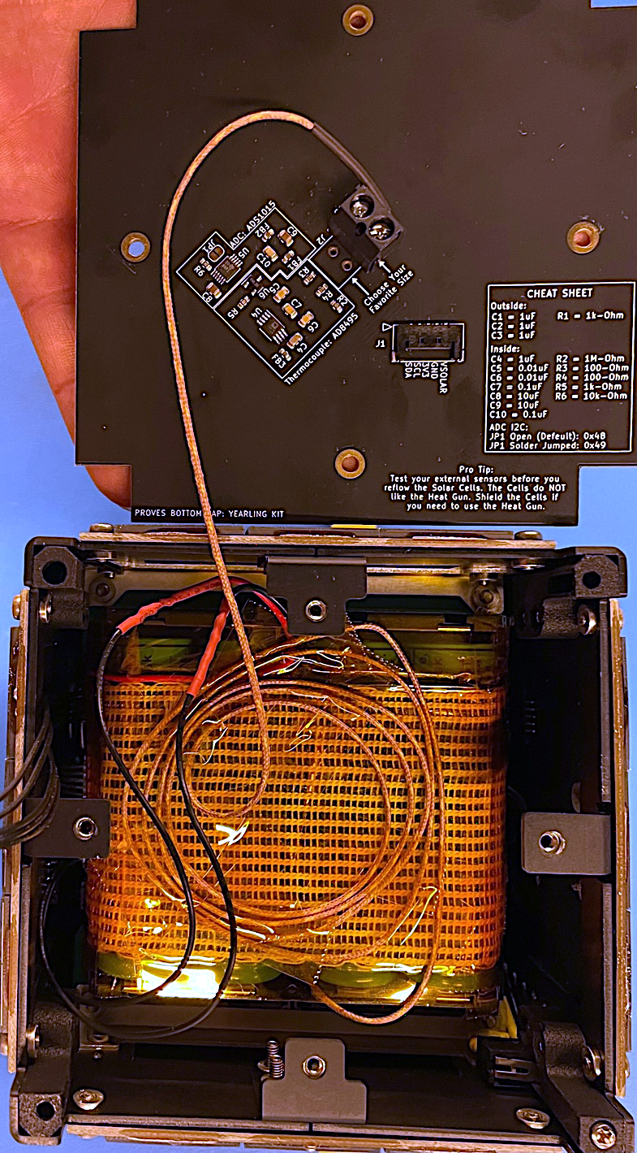

Figure 8.8: Thermal blanket placed over batteries (LEFT). Blanket folded back so that it only covers the edges

NOTE: To fully secure the batteries for a flight model, it is suggested to use space-rated glue to secure the battery cells onto the battery board as well as the thermocouple probe.

1. **Integrating Satellite Feet** 
   1. Installing feet assembly
      1. For this section you will need to use Blue Loctite, M2.5x10mm pan head fasteners and M2.5 locknuts to install the feet.
      2. When installing the feet onto the structure, you will need to make sure to install them so the feet with the switches inside them are all diagonal from one another. This can be seen in figure 8.9.

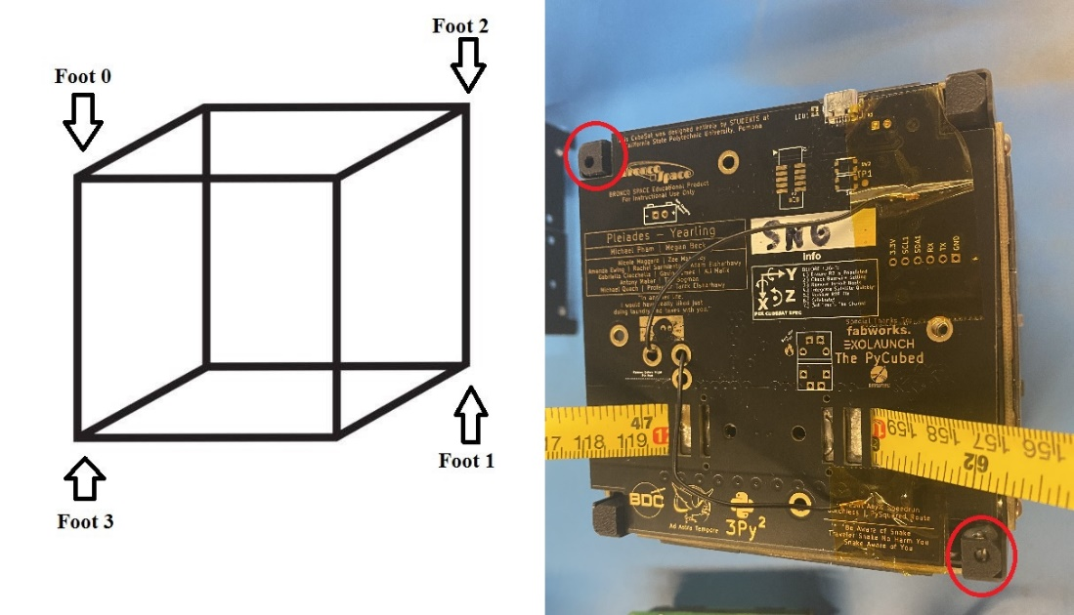

Figure 8.9 Placement of Foot Switches on structure layout (LEFT). Placement of foot switches again shown on completed satellite (RIGHT).

* + 1. To install the feet on the structure, place locknuts in the small openings of the feet as shown in figure 8.10 with the nylon side of the locknut facing towards the interior of the satellite. When installing, make sure to simultaneously push downwards on the top of the feet while also pressing them up against the side of the structure. This will keep them flush against the structure as well as reduce the profile of the satellite so that it fits better in a deployer pod. Be sure not to over-tighten the screws which could lead to stripping of the locknut placement.

**WARNING:** This next step is meant to be permeant, be sure that you are ready to proceed before doing the next step.

* + 1. If you have already screwed the fasteners into place, take them out one at a time and do the following before placing them back. You may have to hold the locknuts in place while doing this as they could fall out of the feet and into your structure. Dip the ends of the 10mm long fasteners in a small amount of Loctite and secure the feet in place.
    2. Torque the fasteners to the specification provided below

**WARNING:** TORQUE SPEC IS 0.59 N-M (5.22 LB-IN), DO NOT EXCEED THIS ON M2.5 BOLTS/FASTENERS.

* + 1. Once the feet are installed on one side, it should look like Figure 8.11 (Depending on how many foot switches are being utilized in the satellite, the amount of assemble foot switches may vary between satellites)

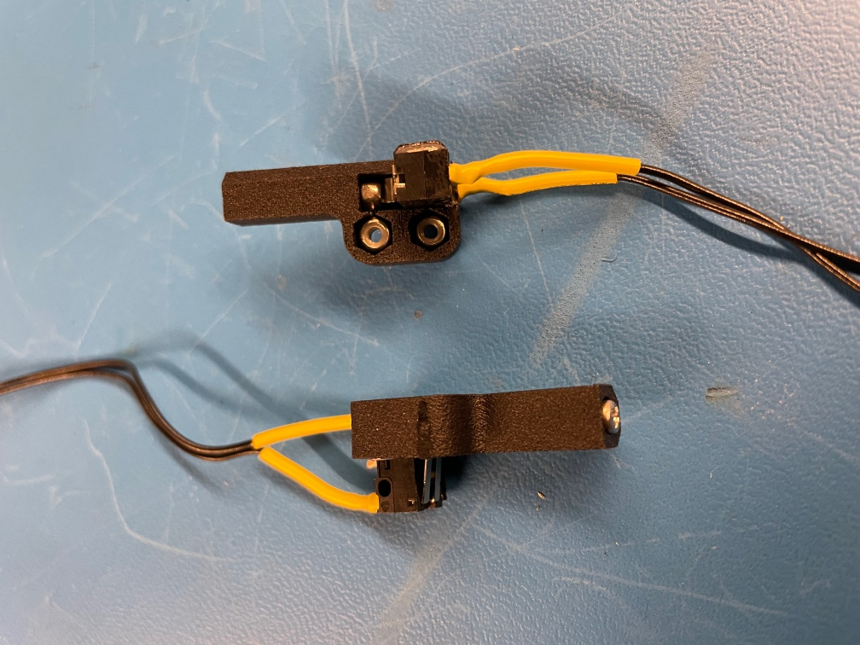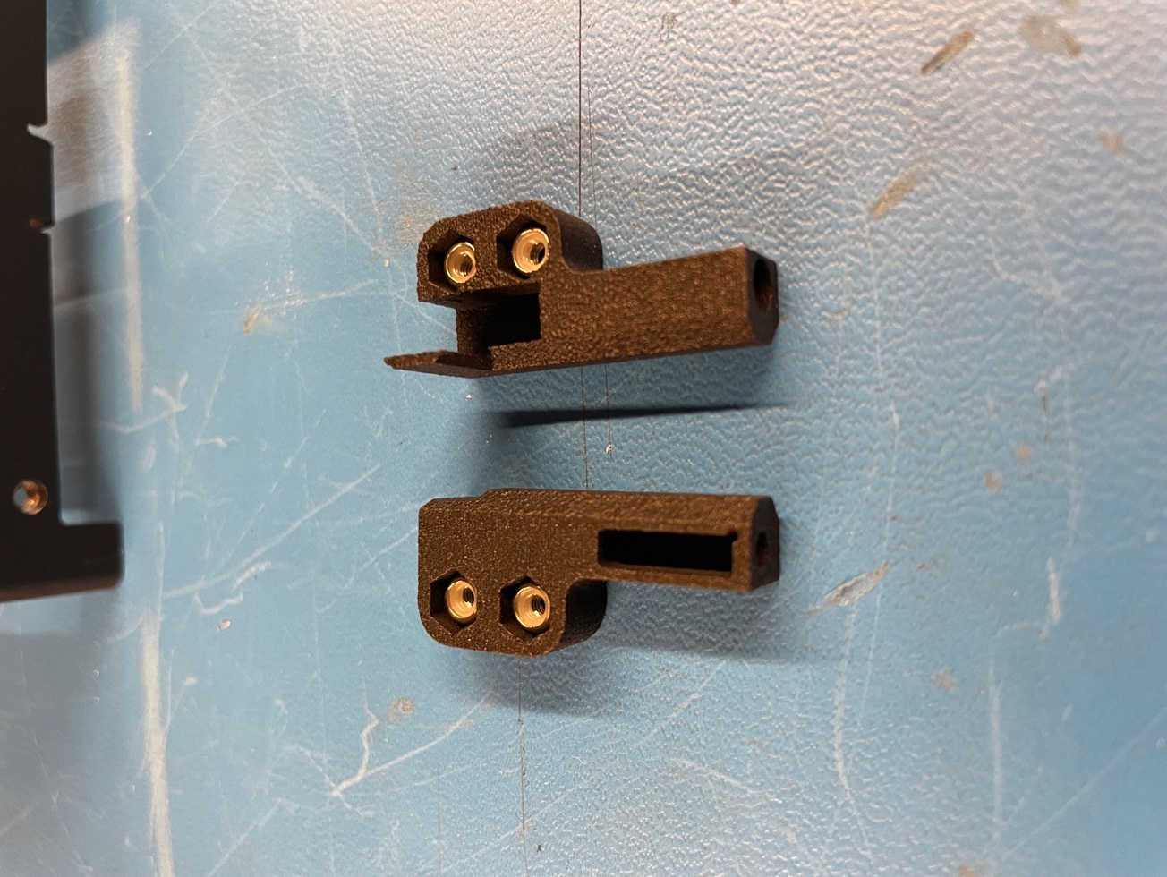

Figure 8.10: (Left) Feet with switch assembly, (Right) the two different types of feet used (two of each used diagonally from each other for top and bottom).

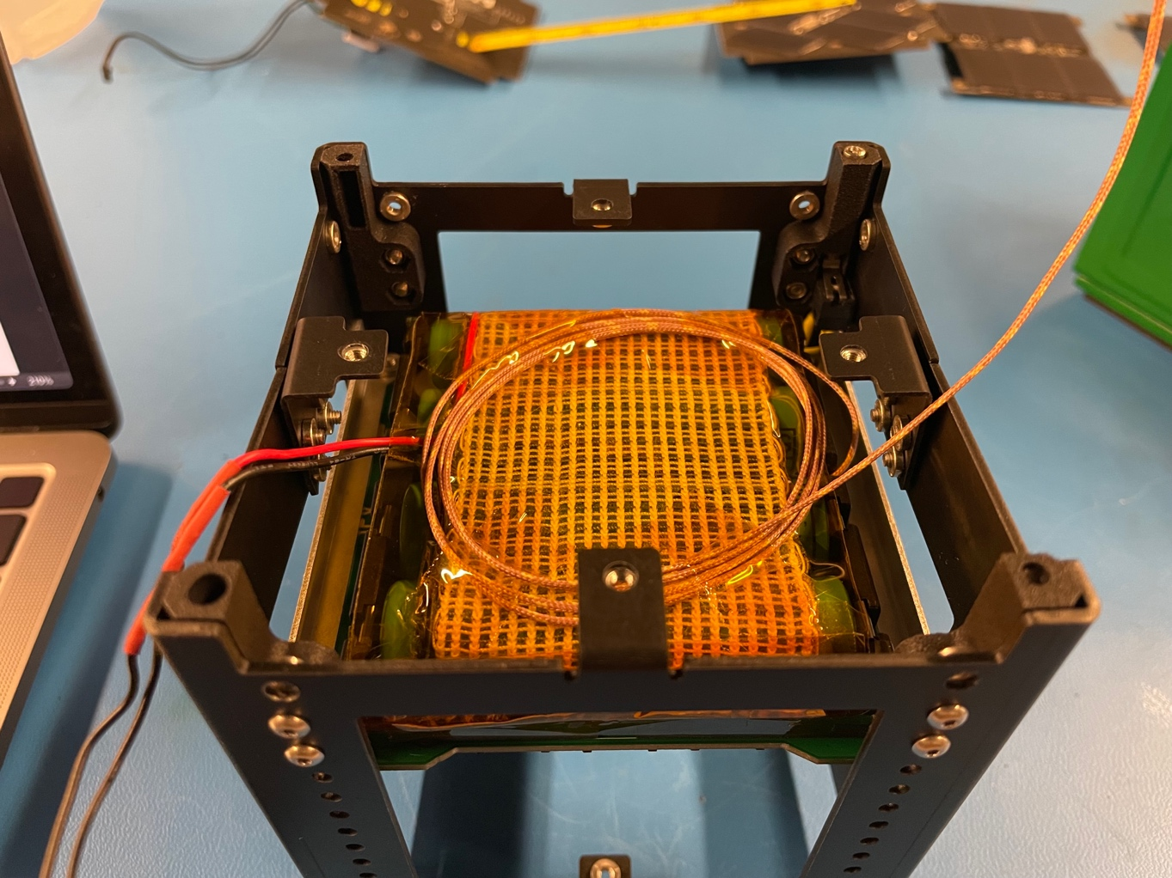

Fig8.11: The two different feet installed in structure (Notice the two different diameters of holes on feet)

1. **Squaring the Satellite** 
   1. It’s Jig Time!
      1. Place structure into jig as shown in figure 8.11. Without taking the satellite out, slide it back and forth multiple times through the jig to square up the structure.

NOTE: If you cannot fit the satellite into the jig, make sure to loosen the fasteners on the structure (not including the feet) and attempt to fit it again.

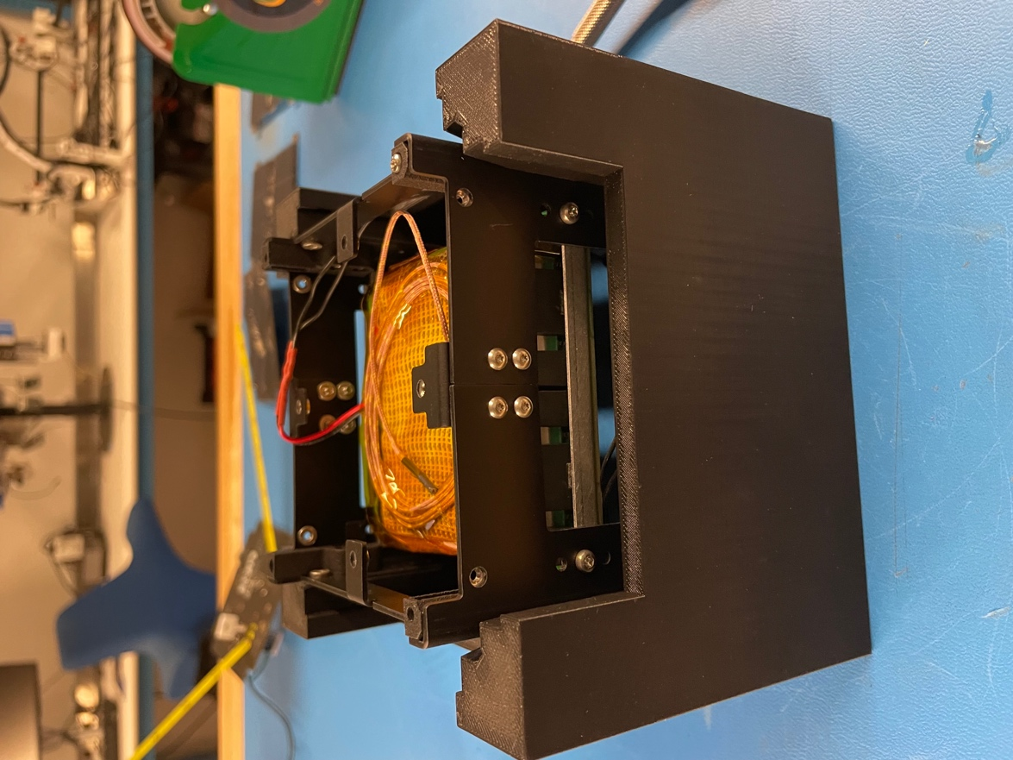

Fig 8.11: Example of how to square the satellite inside a 3D-printed jig.

**WARNING:** The next step is meant to be permanent! Make sure you are set to proceed before going to the next step.

* + 1. Again, without taking the satellite out, unscrew fasteners one at a time and secure them by dipping them in Blue Loctite and placing them back in the structure. Torque the fasteners to the appropriate spec as before. Remember to be careful with the fasteners that are screwed into the small L brackets on the structure as you may accidentally pop out a pre-installed pem-nut if this process is done hastily.

1. **Cable Management**

Due to the number of wires in the satellite, the following steps will be specific to individual connections in the satellite.

NOTE: If wires need to cross the battery board, route them through the sides of the board that have cutouts to ensure that the solar panels will sit flush in later steps.

1. Connections

NOTE: If you are only using 2 feet, connect them to the “Foot 0” & “Foot 2” ports on the battery board and use jumper wires for 1 & 3.

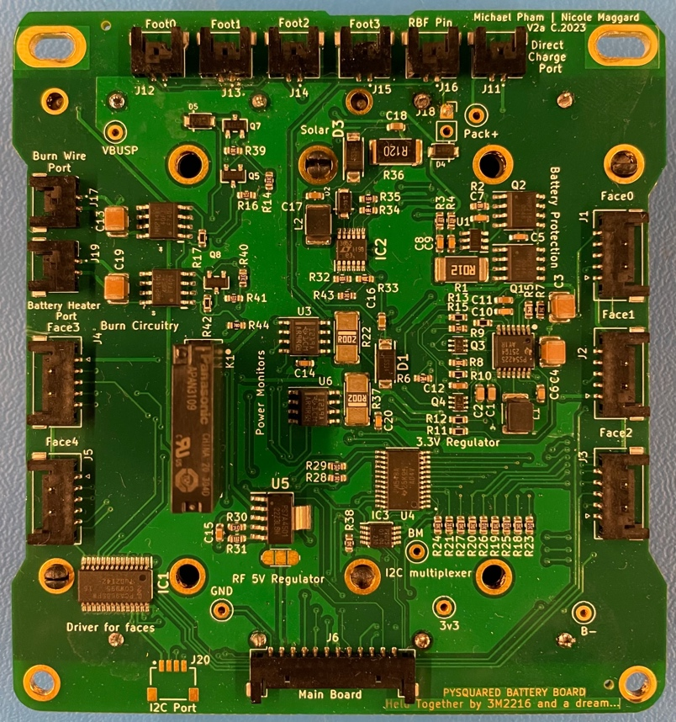

732

632

532

432

132

232

332

Fig 8.12: (Left) An unintegrated battery board with necessary connections boxed in blue

1. Foot Switch Ports: The foot assembly will terminate to a 2-position Pico-Lock connector. For the feet on the bottom of the satellite, pull the connected wires up along the open sides of the battery board.
2. Remove Before Flight (RBF): The RBF assembly will terminate to a 2-position Pico-Lock connector. This will be connected when the top-cap is installed.
3. Direct Charge Port: 2-position to 2-position Pico-Lock connector cable.
4. Face Ports: 5-position to 5-position Pico-Lock connector cable.

* Face 4 is reserved for the bottom or -Z solar face, while Faces 0 to 3 are to be used for the side solar faces of the satellite.

1. Main Board (Top Cap) Port: 12-position to 12-position Pico-Lock connector cable. NOTE: If a 915 MHz RF module is used instead of a437.4 MHz, then a wire in the cable needs to be removed. This can be seen in Figure 8.13 below. This was also mentioned in the pre-integration step for the Flight Controller
2. Burn Wire Port: 2-position to 2-position Pico-Lock connector cable.
3. Battery Heater Port: The battery heater terminates to a 2-position Pico-Lock connector cable.

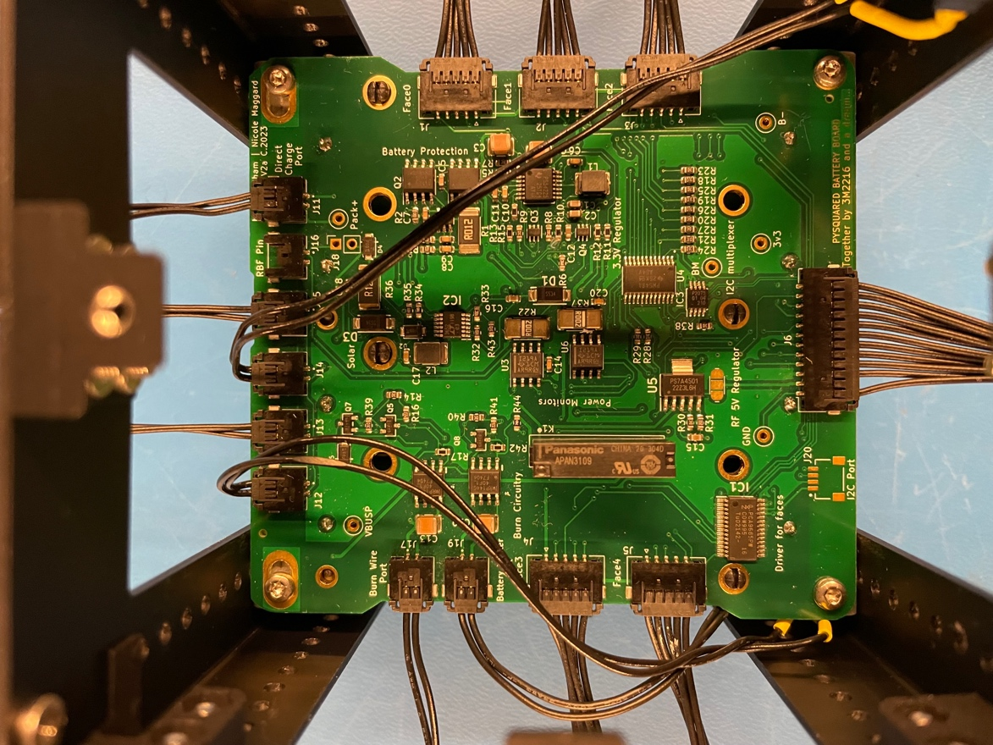

Removed cable position for use of a 915 MHz RF Module

Figure 8.13: Battery board with connectors

1. **Integrating Solar Faces & Top Cap** 
   1. Solar Faces
      1. To tell which face is which, take the top cap and momentarily place it onto the top of satellite as if you were going to mount it. The top has an axis orientation labeled on the top to help guide you, so once you’ve figured out which face is which place it to the side so that you can still use it as a guide.

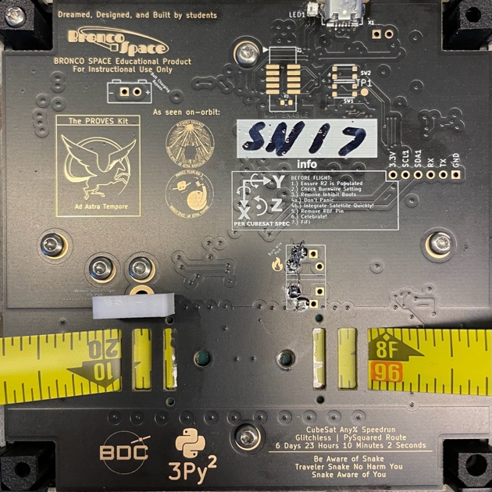

Figure 8.14: showing the orientation diagram on the Top Cap.

* + 1. Now connect each pin-out to the proper face (+-X, +-Y, +-Z) on the satellite. Refer to the axis directions shown on the top cap for guidance. The connections are shown below for all the faces of the satellite.
* Face 0 to +Y
* Face 1 to +X
* Face 2 to -Y
* Face 3 to -X
* Face 4 to –Z

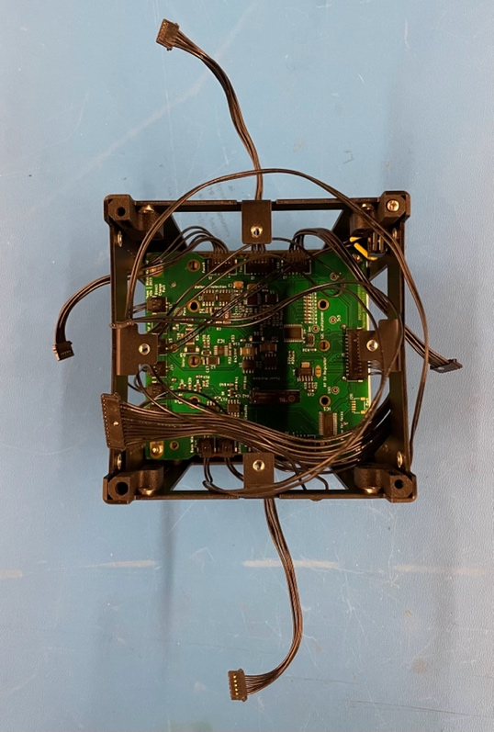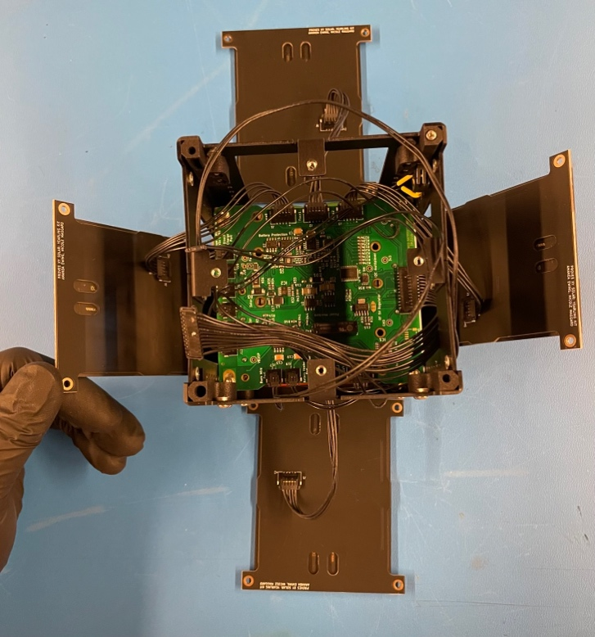

Figure 8.15: Securing the solar faces onto the structure.

* + 1. Secure the solar faces of the satellite to the structure with 5mm stainless steel fasteners as shown in figure 8.14. Do not use Blue Loctite or the torque wrench on these fasteners in case troubleshooting is necessary. This should only be done after all necessary in-house testing is complete.

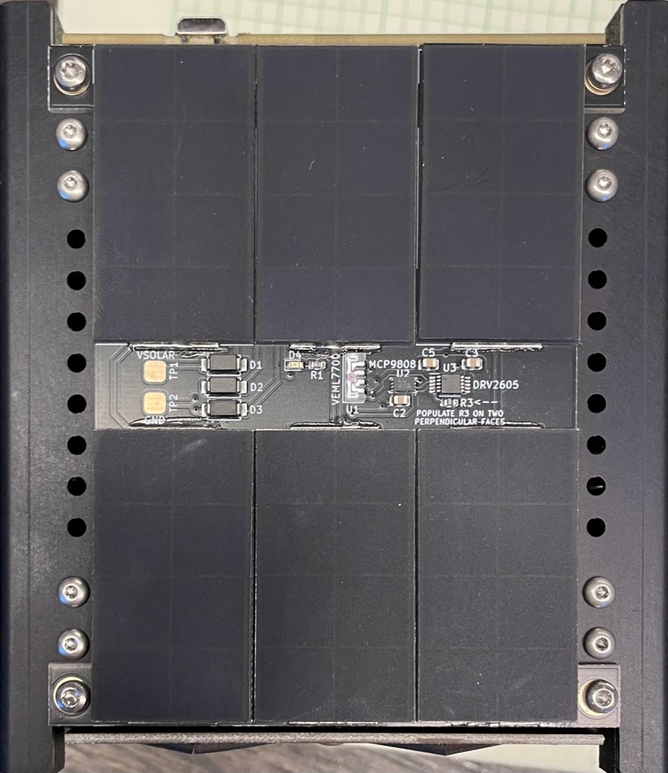

Ensure that the wording on the board can be read correctly when the satellite is positioned with +Z facing up.

Figure 8.16: Securing the solar faces onto the structure.

* + 1. To connect the -Z face, secure the thermocouple wire into the proper terminals on the board. The yellow wire should go into the terminal with the square footprint, while the red wire should go into the terminal with the circular footprint.

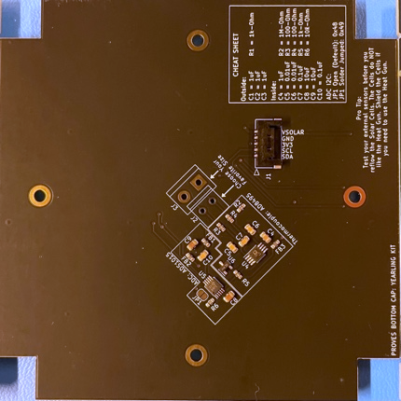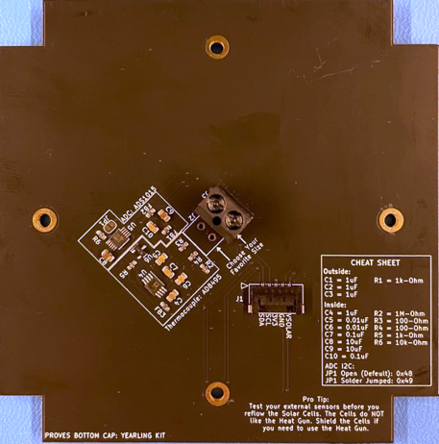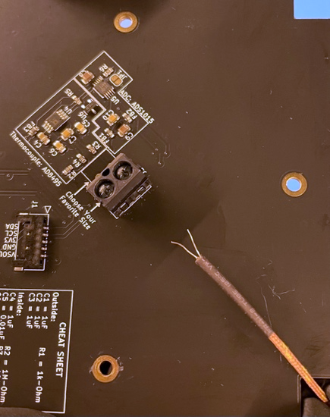

To Face 4

Wire w/ yellow jacket

Wire w/ red jacket

Fig 8.17: Securing the solar faces onto the structure.

* + 1. Connect the “face 4” connection into this face, then secure the face with M2.5x5mm pan head bolts onto the structure.
    2. Moving onto the top cap, connect the “RBF” wire coming from the top cap to the corresponding connector on the battery board before installing the last solar face as seen in the figure below. Connect the two remaining wires to the corresponding connectors on the top cap, they will be the Direct Charge Port and Burn Wire and can also be seen in the figure.

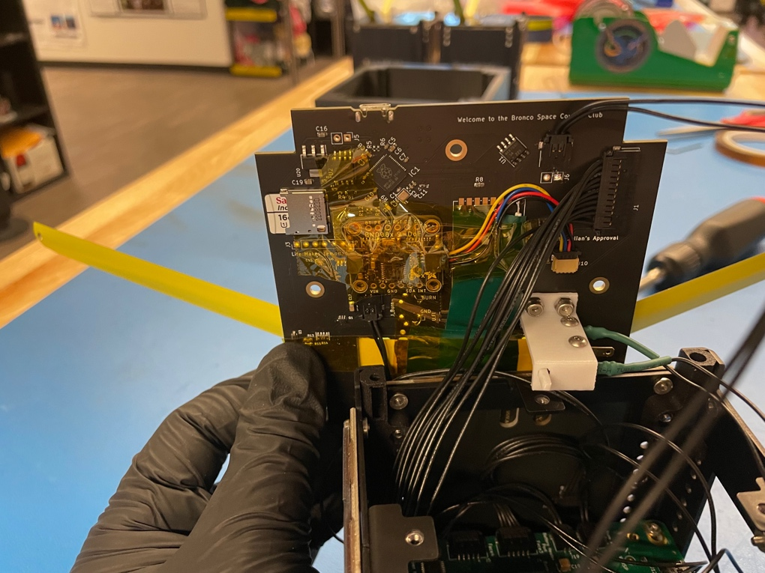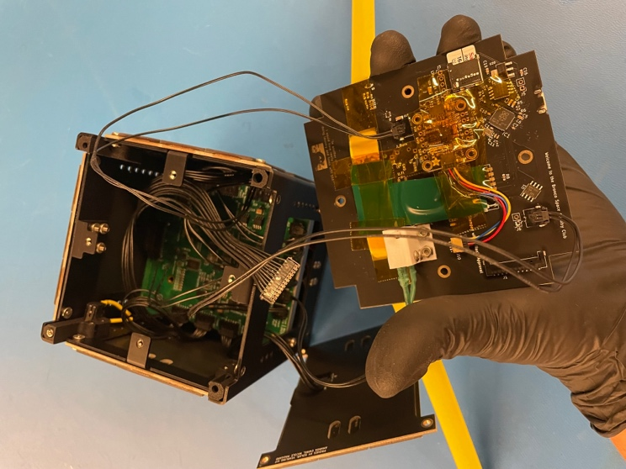

Figure 8.18:

These connections are summarized below:

* Main Board to J1 Port on Top Cap
* RBF Pin to RBF Pin on Top Cap (direct wire connection there is no port)
* Direct Charge Port to J7 on Top Cap
* Burn Wire Port to J8/J_Burn Port on Top Cap
  + 1. Before securing the top cap, have the electronics team do a check of all electronics. This means that the electronics team needs to plug in everything and run tests to make sure everything is working properly. However once this is done, secure the top cap with 5mm stainless steel fasteners.

1. **Final Steps**

NOTE: Install an RBF pin or allen/hex key in the RBF pin slot of the top cap to keep the satellite off when it is not resting on a table

1. Tying down the antenna.
   1. Cut a long section of fishing line to secure the antenna in place around the satellite. A section that is roughly 16inches long should give you enough on the first attempt.
   2. Tie one end of the fishing line to the end of one antenna.
   3. Wrap the line around the satellite, holding it as tight as possible, weave the line across the burn wire and then secure the other antenna in place.

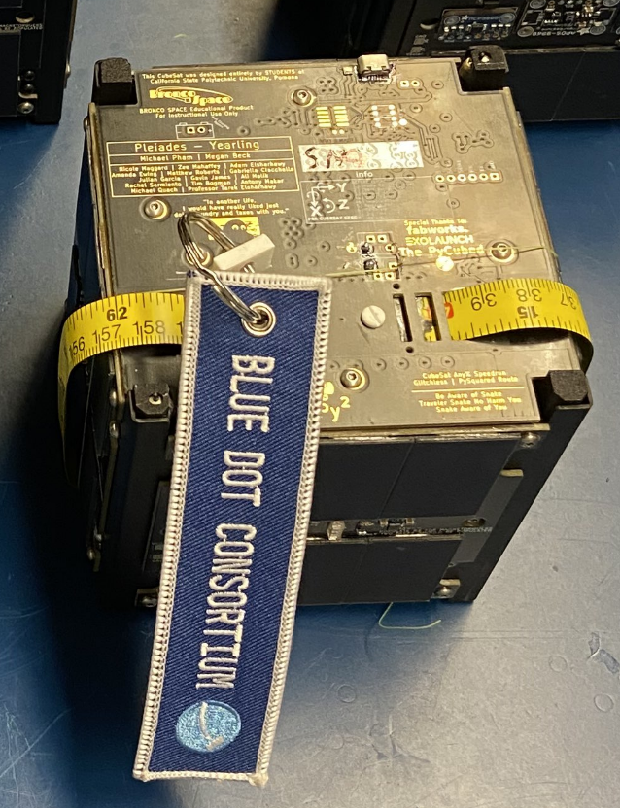

Fig8.15 Finished satellite with RBF pin and antenna tied down securely.

## Chapter 9: Final Tests – Integration Procedure

### Final Check for Electronics

The Final Check for the Electronics in the Integration process involves running the same flat sat test code to ensure everything is communicating with each other when stacked in the satellite. A fully assembled structure is required for this test:

1. Plug the Micro USB cable into the satellite
2. Make sure the feet switches and RFB Switch are not depressed. The satellite should be on before continuing (this can be verified by probing the 3.3V pin on the top of the flight computer).
3. Open a terminal at the satellites given COM port.
4. Type the following command: “import flatsattest”
5. The following set of results should appear:
6. If the results do not appear successful for every component, follow these steps for troubleshooting:
7. The LED Driver may not be operating correctly, which may cause issues with being able to view sensor data from the solar boards as the sensors may not receive power. If the test did not return a success for initializing the LED Driver, then follow these steps:
8. Load the “I2Ctest.py” file into the “PYSQUARED” Directory
9. Type the following into the terminal “import i2ctest”
10. If the readout does not return an I2C address at 0x56 then the LED Driver is not working and the battery board should be replaced
11. The I2C Multiplexer may not be operating correctly, which may cause issues with being able to view sensor data from the solar boards as the individual bus is not being selected properly. If the test did not return a success for initializing the I2C multiplexer, then follow these steps:
12. Load the “I2Ctest.py” file into the “PYSQUARED” Directory
13. Type the following into the terminal “import i2ctest”
14. If the readout does not return an I2C address at 0x72 then the I2C multiplexer is not working and the battery board should be replaced
15. The solar board sensors may not be operating correctly, which can be an issue with either the solder joints on the sensors or an I2C fault. If the test did not return a success for initializing the temperature sensor, light sensor, or motor driver then follow these steps:
16. Load the “Solartest.py” file into the “PYSQUARED” Directory
17. Type the following into the terminal “import solartest”
18. If the readout does not return an I2C address at 0x26 then the Temperature sensor is not working. If the readout does not return an I2C address at 0x78 then the Light sensor is not working. If the readout does not return an I2C address at 0x20 then the motor driver is not working. In the case of the bottom face, if the readout does not return an I2C address at 0x35 then the ADC is not working for the Thermocouple.
19. If any of the sensors are not working, then check the solder joints on those sensors and reflow the sensors if necessary.
20. If resoldering the sensor does not resolve the issue, then it may become necessary to replace the solar board.
21. The power monitors may not be operating correctly, which may cause issues with being able to view data revolving the power usage and power input. If the test did not return a success for initializing input and/or output power monitors, then follow these steps:
22. Load the “I2Ctest.py” file into the “PYSQUARED” Directory
23. Type the following into the terminal “import i2ctest”
24. If the readout does not return an I2C address at 0x40 and/or at 0x4F then the one or more of the Power Monitors is not working and the battery board should be replaced

### One Final Jig Test

It is important that the satellite is as square as possible so that it will properly fit into its deployer. Just as before, slide the satellite through the Jig.

### Vibration Test

To qualify for space, the satellite will need to complete a random vibration test, so that it may ride on the rocket. Check with your flight provider for more information about vibration testing.

### Long Range Communications Test

To Ensure the satellite is operating properly, it is important to see if the satellite can be heard from at distances greater than 50km.

### Thermal Vacuum Chamber Test

To obtain an accurate idea of how the satellite will perform in space, the satellite should be exposed to extreme temperature shifts and vacuum environments.

**CONGRATULATIONS! You have just completed the integration of your satellite!**

# Integration Procedure Checklist

Start Date and Time:_________________ End Date and Time:_________________

|  |  |  |
| --- | --- | --- |
| Task | Notes | Initials |
| All materials needed (All bolts that will be used for installing, installation tools, mats for working on, all parts of the entire system) |  |  |
| CNC Feet loosely installed (except for the two with switches) |  |  |
| All of the Main “U” L-Brackets loosely installed on one Main “U” |  |  |
| All electronics boards ready for Integration |  |  |
| One side of electronics boards loosely installed on one Main “U” |  |  |
| Other Main “U” attached on other side of electronics boards and L-Brackets |  |  |
| Feet with switches installed |  |  |
| Top and bottom boards loosely installed onto structure |  |  |
| Flat surface (Have something like machined tabletop, glass piece, etc. to work on) |  |  |
| Square out the structure (Utilize the jig) |  |  |
| Put Loctite and torque to spec on all bolts on all L-Brackets |  |  |
| Put Loctite and torque to spec on all bolts on all PCB Brackets |  |  |
| Put Loctite and torque to spec on all bolts on all Feet |  |  |
| Check all electronics that they are properly working |  |  |
| Put Loctite and torque to spec on all bolts on the Solar Panels |  |  |
| Put Loctite and torque to spec on all bolts on the top and bottom boards |  |  |
| Final torque check of all bolts on structure |  |  |
| Final electronics check |  |  |
| Tie down antennas |  |  |